The mediator as conductor: Repertoire
David Mitchell
Emotional intelligence
The fifth article in the ‘Mediator as a conductor’ series

Musical connection: Emotional Intelligence (EQ) in a figure such as a leader, a conductor or a mediator both leads and shares, and inspires an interaction with others. At a certain point there is a consensus (entrainment) and a positive mood/flow occurs. This is often called the Aha! moment in mediation. I am grateful to Tasmanian mediator, Gail Cork who suggested this symphony as a ‘stunning example of emotional intelligence in the form of restraint and perfect timing can be found in Symphony No 3 in C Minor by Camille Saint-Saëns. Although it's known as the Organ Symphony, the organ is scarcely heard until 28 minutes into the 36 minute work. When it finally arrives, it does so with a crashing sustained C Major chord which heralds a dramatic shift and brings the entire orchestra in behind it for the final movement”. Watch this happen on YouTube.

Emotional Intelligence
The effective negotiator or mediator must take into account not only the economic, political and physical aspects of the process, but also the emotional tenor of themselves as well as that of all of the parties.
The 1970s and 1980s heralded a ‘New Age’ that rebelled at the post World War II rationality and hard work ethic in favour of spirituality, autonomy and psychology. This generated a plethora of books on self-help, get rich quick schemes, and business success theories and ideas. A notable success was Daniel Goleman’s concepts contained in his 1985 book Emotional Intelligence. Goleman, an astute observer with an inquiring mind, promoted the idea that humans were controlled by their emotions, often swamping rational thinking and behaviour. Those people who could control their emotions possessed ‘emotional intelligence’(EQ) and were more successful in life and in business. Moreover, by following his model, EQ could be enhanced, and those who displayed lower EQ, could learn (and be taught) how to become more emotionally intelligent. Successful business leaders and entrepreneurs were considered to have high EQ and courses in EQ became, and often, still are, mandatory for those seeking advancement or promotion.
Mediation, emerging from a judicial ethos with its rigid adherence to reason and logic, was slow to adopt EQ concepts. Fisher and Uly’s 1983 seminal book on mediation advised the mediator to ‘separate the people from the problem’. Similarly, Jones (1999) called mediation an ‘emotion-free zone’. Schreier’s report on mediation training’s neglect of emotion was one of many at the turn of the century to propose teaching mediators emotion training including EQ. Kelly more recently published a very readable paper with some caveats for mediators considering EQ.

Concepts of EQ
Emotional Intelligence (EQ) was first defined by Salovey and Mayer as, ‘… the ability to monitor one’s own and others’ feelings and emotions, to discriminate among them and to use this information to guide one’s thinking and actions’ . Goleman defined EQ as ‘the capacity for recognising our own feelings and those of others, for motivating ourselves, and for managing emotions well in ourselves and others’.
Whilst Goleman’s book made him the ‘unofficial’ expert on EQ, he had borrowed heavily from Salovey and Mayer’s (1990) work on EQ and Boyatzis’ (1982) work on competencies. Salovey and his co-workers continue to publish on EQ. Both have their models of EQ and, progressively, the business market has added their own interpretations such that currently the consensus model is number 3.0 (Emotional and Social Competency Inventory (ESCI).
Goleman considered that there were four (originally five) main categories (he called them ‘clusters’) that covered a series of skills or competencies that collectively measured EQ. The 25 foundation competencies have been shaved down to twelve.
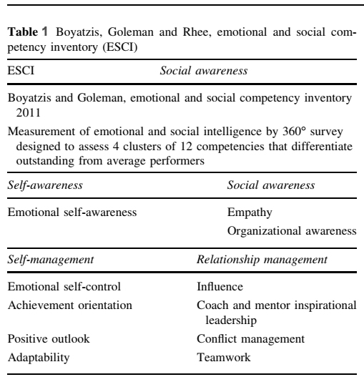
Downloaded from Segon and Booth. DOI 10.1007/s10551-013-2029-z
Self-awareness and self-management deal with the inner ‘self’, and social-awareness and relationship management deal with the external ‘others’. Most experts consider that a good manager does not have to have high EQ levels in all competencies.
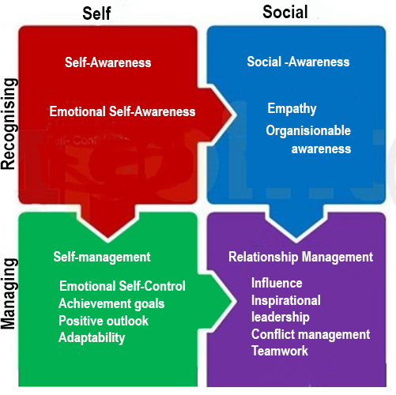
Fig.1. Alternative model for EQ adapted from Goleman. Emotional Intelligence,
showing the relationships between clusters and their allocated competencies.

Delphic tablet inscribed ‘Know Thyself’
(Self-awareness)
Self-awareness is the ability to know and understand the ‘real self’: strengths and weaknesses; beliefs and values; habits and actions; virtues and vices. Knowing these areas that generate positive or negative emotions allows a person (e.g. a mediator) to take control and manage their emotions which is part of the self-management realm (cluster).
A quote attributed to Sun Tzu says, ‘If you know the enemy and know yourself, you need not fear the result of a hundred battles.’
Sun Tzu’s word, the 'enemy’ could just as easily be changed to any other person, transaction, interaction or dialogue with another.
Thus, being able to recognise, identify and understand others’ emotions, narratives and worldview (social-awareness) can help a mediator better interact with, and manage relationships with, others (relationship management).
Learning EQ
- Self-awareness
Training to understand and manage strong emotions helps a mediator
(1) build tolerance for expression of emotion,
(2) develop detachment and reduce stress,
(3) inculcate patience and humility, and
(4) promote a realistic understanding of outcomes .
Feedback in Scheirer’s research on mediator training in EQ deduced that EQ is ‘part talent, part gift, part personality, part experience, part training.... but most of it is life experience. You can’t just act like a mediator; you must live your life that way’
Bowling and Hoffman (2000) suggest that persistent reflective experience, discipline, and intention, more than intellectual inquiry, are needed to learn optimal self-awareness. They refer to meditation, yoga, religious discipline, and psychological inquiry as useful practices to assist a mediator in developing authentic presence; integration of mind, body, and emotions; and a higher level of self-awareness.
It is pertinent to note that an authentic leader has many of the same attributes as a high rated EQ manager/leader (See Fig.2). In turn there is a correlation between both in Aristotle's concept of a good person. To paraphrase Aristotle: ‘In the right hands, with the right person, at the right time and for the right reasons, a good mediator will create a positive result from a mediation.’
Thus, learning EQ revolves around continuing self-education in some of the following:
  - Reflective training and consistency in use
  - Mindfulness, compassionate meditation, loving kindness meditation
  - Adherence to Aristotle’s virtue ethics and practical wisdom
  - EQ assessment questionnaires/profile. Whilst none are completely accurate, they can be used as a form of ongoing assessment of learning
  - EQ leadership courses or seminars. These are high on rhetoric and low on practical information, yet can suit some individuals
  - Seminars or publications on Authentic Leadership
  - Wellness programs including diet, nutrition, exercise, yoga and sleep cycles
  - Association with like-minded peers, mentors, supervisors and external contacts
  - Read, absorb and share
  - Add appropriate music to a daily regimen

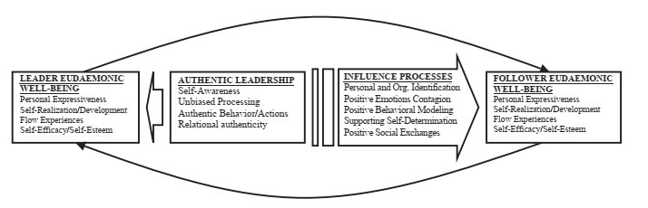
Fig.2 Authentic leadership, EQ and qualities of a ’good person.
Downloaded from https://doi.org/10.1016/j.leaqua.2005.03.002

The downside of EQ
1. Negative effects of empathy
Humans can react positively to another’s pain or distress in one of three ways:
  - Sympathy defined as feeling a person’s distress and absorbing it so they feel better. Yet the sympathiser now carries those emotions.
  - Empathy defined as caring so much for a person’s distress so as to want to feel their emotional distress as a means of understanding. This is often referred as ‘walking in another person’s shoes for a day’. This can lead to empathy contagion wherein the emotions of the distressed person can contaminate the mediator, affecting their judgement or, conversely, the emotions of the mediator can contaminate the distressed mediatee. A mediator who is not sufficiently self-aware can, over time, develop empathy distress/overload and function at lower and lower levels of competency.
  - Compassion (sometimes called mature empathy or empathic compassion) is defined as ‘the emotional perception and recognition of the suffering of others and the desire to alleviate it, understanding the universality of suffering, feeling moved by the person suffering and emotionally connecting with their distress, and tolerating uncomfortable feelings (e.g., fear, distress) so that we remain open to and accepting of the person suffering.’
The two main differences from empathy are not taking on the person’s distress/emotions (thus avoiding empathy contagion and empathic overload) and secondly, the desire to do something about it. It is the drive to do something for the ‘distressed’ person that makes compassion superior to, and safer than, empathy. To be compassionate and show compassion requires a state of self-compassion, a learnt behaviour.
Klimecki, Leiberg, Ricard, and Singer have shown that empathy stimulates different areas in the brain compared with compassion and that the empathy signals were negative compared to the compassion signals.
Svenaeus makes a strong case for mature empathy (i.e. compassion) being an essential part of Aristotle’s phronesis or practical wisdom which increases a mediator‘s chances of achieving a good outcome.

2.EQ has removed ethics from its competencies
The gradual shift in EQ towards managerial behaviour and a focus on results at any cost has led to the removal of any ethical competency in the various iterations of EQ. More and more managers and leaders are referred to as high EQ performers yet many are resorting to unethical behaviour such as using empathy and perceived trustworthiness and authenticity to unduly influence their workforce. Segon and Booth have put forward a newer model for EQ that re-establishes ethics as an integral part of an authentic EQ leader. Given the increasing numbers of high profile or high flyer CEOs and managers who have been exposed as criminals (think Enron or Ponzi schemes) this new EQ competency chart is timely. See Fig.3.

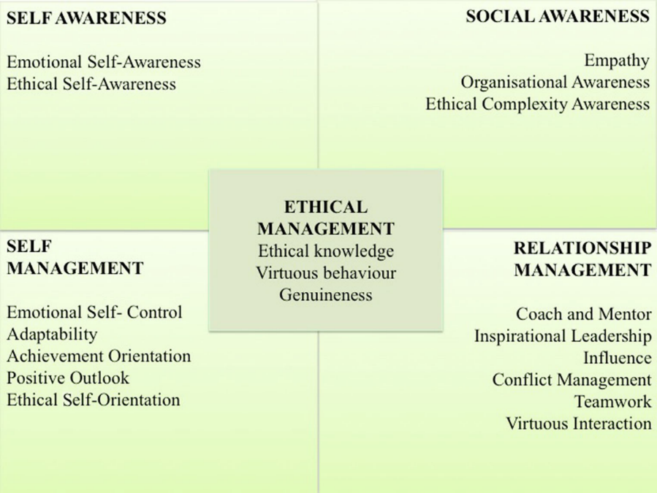
Fig.3. Segon & Booth:A proposed exemplar of an ethically informed ESCI framework with Ethics as a foundation competency. Downloaded from DOI 10.1007/s10551-
Conclusion
EQ is a difficult instrument to learn and play. It is person-centered, not work/skill centered. Self-compassion leads to compassion for others and onto practical wisdom and appropriate action. A good, experienced mediator as conductor with innate and acquired EQ can use it within himself/herself and achieve the greater good for the mediatees.

https://www.youtube.com/watch?v=ZWCZq33BrOo
Edward J. Kelly and Natalija Kaminskiene. 2016. Importance of emotional intelligence in negotiation and mediation. International Comparative Jurisprudence 2 (2016) 55-60. http://dx.doi.Org/10.1016/j.icj.2016.07.001
R. Fisher, W. Ury. 1983. Getting to yes: negotiating agreement without giving in. Penguin Books, New York .
Schreier, L. S. (2002). Emotional intelligence and mediation training. Conflict Resolution Quarterly, 20(1), 99–119. doi:10.1002/crq.13 quoting Jones, T., and Bodtker, A. Mediating with Heart in Mind Communication Insights on Mediation Process and Training: The Role of Emotion. Community Outreach Workshop, International Communication Association Conference, San Francisco, May 1999 .
Schreier. ibid
Kelly ibid ²
Salovey, P., & Mayer, J. D. (1990). Emotional intelligence. Imagination, Cognition and Personality, 9, 185–211.
Salovey, P., & Mayer, J. D. (1990). Emotional intelligence. Imagination, Cognition and Personality, 9, 185–211.
Segon, M., Booth, C. Virtue: The Missing Ethics Element in Emotional Intelligence. J Bus Ethics 128, 789–802 (2015). https://doi.org/10.1007/s10551-013-2029-z
Segon, M., Booth, C. ibid ⁹
Segon and Booth. ibid
Schrerier ibid⁵
Schreier ibid⁵
Schrerier ibid⁵ quoting Bowling, D., and Hoffman, D. “Bringing Peace into the Room: The Personal Qualities of the Mediator and Their Impact on the Mediation.” Negotiation Journal,Jan. 2000,pp. 5-28.
Remus Ilies, Frederick P. Morgeson, Jennifer D. Nahrgang, 2005. Authentic leadership and eudaemonic well-being: Understanding leader–follower outcomes, The Leadership Quarterly, Volume 16, Issue 3, 2005,
Annamaria Di Fabio and Donald H. Saklofske, Personality and Individual Differences, https://doi.org/10.1016/j.paid.2020.110109
Olga M. Klimecki,Susanne Leiberg,Matthieu Ricard,and Tania Singer. 2014 Differential pattern of functional brain plasticity after compassion and empathy training. doi:10.1093/scan/nst060 SCAN (2014) 9, 873^87 .
Fredrik Svenaeus. 2014. Empathy as a necessary condition of phronesis: a line of thought for medical ethics. Med Health Care and Philos (2014) 17:293–299. DOI 10.1007/s11019-013-9487-z .
Segon and Booth ibid ¹⁰

