The Mediator as a conductor six (6) part series.
This is a poetic description of a mediator as an orchestral conductor.
Research has validated that :
- humans respond to rhythm and movement
- an orchestral experience is enhanced by the entrainment of conductor, orchestra and audience via the conductor’s movements (body, arms, baton) and by her non-verbal facial movements/expressions. The latter is only viewed by the orchestra or TV/video/film watchers. If the conductor turns around and faces the ”audience as the orchestra” then she could become the mediator and mediatees become the orchestra (e.g. the strings and the winds).
- The entrainment can continue even when the audience looks at the orchestra or even close their eyes!
The mediator’s opening greeting, explanations, receiving the mediatees narratives and the setting of an agenda is a wonderous chance to establish this entrainment. The conductor’s use of different songs/compositions (in the form of narrative, Transactional Analysis, Emotional Intelligence, NLP, Compassion) can create a flourishing mediation
The mediator sits with you
Looking and observing,
Listening and hearing,
Feeling and understanding.
With chosen words in language known,
With unspoken language in face and body,
Batonless, yet conductor-like, she entrains heart-minds
and creates synchrony that becomes a new, finished symphony.

David Mitchell

The Mediator as Conductor
David Mitchell
A mediator, conducting a mediation, must rely on presence, trustworthiness, impartial professionalism, and compassionate listening skills Read more from the first in a series of Musings of a mediator: the mediator as a conductor series
The mediator sits with you
Looking and observing,
Listening and hearing,
Feeling and understanding.
With chosen words in language known,
With unspoken language in face and body,
Baton less, yet conductor-like, she entrains heart-minds
and creates synchrony that becomes a new, finished symphony.
David Mitchell
Google Search has a lot to answer for. On searching for articles on Kubler-Ross’ 5 Stages of Grief; I was directed to the fourth movement of Schubert’s Great Symphony No.9 which is considered to contain these 5 stages musically. Directed by Google to YouTube, I watched and listened carefully. First time through, I was unconvinced. Second time, I found myself watching the conductor as I listened. Suddenly, the five stages became obvious and the music reflected each of the stages accurately. The conductor’s charisma, authority, professionalism and implicit knowledge of the symphony entrained me. His movements, of trunk, arms, head , baton, and facial movements and expressions entrained orchestra, and audience (in this case, me) such that I moved, heard and became part of that musical piece.
It occurred to me that a mediator is like a conductor. I was not the first to think of this. Google search found a wondrous article by Schechter relating the stages within a mediation to musical beats, tempo, and collaboration (entrainment with the mediator):
“No baton is necessary for this conductor (the mediator), but the skills
required to wrestle sixty musicians into harmonious compliance are
strikingly similar to those of a mediator faced with multiple agendas and the
need to create an atmosphere where point and counterpoint combine into a
theme all can follow.”
This is an article worth reading.
Schechter describes the musical connections between mediator and mediates whereas this article will focus on why this can happen and point to how to use this information .
- The Neural Response to Rhythmic Sound
Socially, before speech, words, reading and writing existed, communication consisted of gestures, movements (including dance) and non-verbal utterances. Within humankind there is an integral connection to rhythm, unconsciously expressed in our day-night circadian rhythm, and the rhythmic switching on/off of hormonal release and neurotransmitter production. These internal rhythms are affected by external rhythmic stimuli (e.g. music) in turn affecting groups of brain cells called neural oscillators. Neural oscillations are correlated with the perception of beat, temporal regularity of a sound sequence and tempo.
“ A rhythmic stimulus can entrain these oscillators, and the neurons carry on responding at the entrained interval after the stimulus has stopped, exhibiting a “memory” of the interval. “
- The Neural Response to Rhythmic Movement
Strong connections exist in humans between beat and movement. Using EEGs (Electro-encephalograms) Nozaradan outlines how music spontaneously entrains humans to move whilst “movement influences the perception of musical rhythms.”
Kumar and Morrison take this one step further in emphasising that music processing and cognition rely on visual clues : the movements of musicians and conductor determine the quality of the experience. The success of an orchestral piece relies on the conductor employing non-verbal movements like appropriate eye contact, rapid pacing, modulation of voice or mouthing of words and rhythmic body movements with baton, arms, head, torso and via facial gestures and expressions,.Such mechanisms and manoeuvres entrained the orchestra and the audience. Kumar and Morrison found that the audience was less entrained suggesting they did not experience the frontal and facial movements of the conductor suggesting that the conductor face the audience or a video of the conductor from the front would enhance the musical experience.
A singular example of this is the 1987 film, ”Children of a lesser God” wherein a young William Hurt acts out as a conductor and a listener of Bach’s Concerto for Two Violins to explain and share his joy of music to a beautiful deaf teacher (Marlee Martin). His actions became the music and her brain absorbed, processed and became entrained by these visual signals creating a unique musical experience for both.

3.The Mediator as a Conductor
Mediators, including conductors and orchestra, “ are active carriers that “transform, translate, distort, and modify “.
A mediator, conducting a mediation, must rely on presence, trustworthiness, impartial professionalism, and compassionate listening skills. Verbal interaction is primarily restricted to pre-mediation contact, opening delivery, listening to the mediatees’ narratives and collaborating in agenda setting and during each one-on -one breakout sessions . Yet by functioning like an orchestral conductor, and interacting with the mediates as if they were an orchestra, she can at all times use gesture, movement, facial expressions and eye-contact to shift the positions of opposing mediatees towards entrainment and possible resolution.
How to become a Mediator as Conductor
All conductors require specific skills training. So, too, do mediators who wish to conduct. The mediator has a range of skills and ‘orchestral pieces or symphonies’ available through :
- NLP
- Narrative theory
- Transactional Analysis
- Emotional Intelligence
- Compassion
Each of these symphonic techniques will be developed over the next few issues of Pulse Newsletter.

The Mediator as Conductor Part 2
The narrative symphony
The Second in the series The Mediator as Conductor

David Mitchell

If a mediator is to be a conductor, then there has to be a repertoire of techniques, akin to symphonies and musical works by composers. I have chosen five pieces to illustrate this concept, which will be published over successive issues of Pulse.
Follow on articles in the Mediator as Conductor series (parts 2-6)
2. The narrative symphony : Lord of the Rings (Stephen Oliver)
3.The neuro-linguistic programming (NLP) focus on the senses: The Ride of the Valkyries in Apocalypse Now
4. The Transactional Analysis (TA): trio divertimento for violin,
cello and viola
5. The Emotional Intelligence (EQ) experience: The Organ Symphony (Saint-Saëns)
6.The Compassion arrangement: “Piu Jesu” from Lloyd Webber’s Requiem sung by Sarah Brightman and Paul Miles-Kingston

The Narrative Symphony applied to Mediation

Musical connection: My favourite narrative symphony is Stephen Oliver’s The Lord of the Rings , commissioned by the BBC for its dramatisation of Tolkien’s masterpiece.

The mediatee’s hope
If I ask you for help
Will my words move you
To listen
To hear
To understand
To accept
So my healing begins
- David Mitchell
‘We dream in narrative, day-dream in narrative, remember, anticipate, hope, despair, believe, doubt, plan, revise, criticise, gossip, learn, hate and love by narrative’
In the opening stages of mediation much attention is given to each mediatee’s ‘story’/narrative summarising their view of the issue/conflict. The two stories are usually significantly different, yet presented with honesty, truthfulness and conviction. From this, the mediator provides a reflective, non-judgemental summary of each speaker’s narrative. Mediators are instructed to listen for salient aspects of each speech and to use any specific language and /or words that were used. If not looked for, nuances, double or hidden meanings, poor reality/perception and or comprehension can be missed. Moreover, finding an acceptable agenda list can be more difficult. Narrative theory can increase a mediator’s recognition-awareness and provide more meaningful agenda items.
Stress, trauma, emotions and life-issues can create a flawed or skewed narrative that can disrupt, divert or destroy a mediation. Williams suggests an appropriate narrative, in life-long practice and actions, provides a coherence, a unity for life.
‘To be ourselves we must have ourselves — possess, if need be re-possess, our
life-stories. We must “recollect” ourselves, recollect the inner drama, the narrative,
of ourselves. A man needs such a narrative, a continuous inner narrative, to
maintain his identity, his self.’
Knowing what to do and how to do it in such cases, can create a more positive mediation and outcomes.
Background to narratives
‘We have, each of us, a life-story, an inner narrative — whose continuity, whose sense, is our lives. It might be said that each of us constructs and lives, a “narrative,” and that this narrative is us, our identities.’
Narratives are socially-constructed, outside-in developments, from parents, social contacts, home, school, community and beyond. From birth onwards every human is establishing, adding, developing and refining a unique narrative. Speech was not required. ‘Preverbal and non-speaking children are able to share an experience, recount an event, and tell a story in collaboration with an intimate adult who provides
the words’
Before speech came observation, social interaction, imitation, deliberation, calculation and construction of an identity, a self or self-hood. Through trial and error, a child’s movements, body language, expressions, sounds, utterances, and feedback develop into a communicative ‘language’ that identifies and asserts itself as a narrative identity. As a person learns and ages, their narrative changes with the social climate.

The philosopher’s view of narrative
The French philosopher, Paul Ricoeur, called this narrative identity ‘self’ or selfhood. He proposed that this uniqueness was internal and protected. Another self (‘Self as another’) was used to communicate and interact with the outside. There could be many variations of this self as another, depending on the interaction/communication/context (e.g. self as another student or sportsperson or speaker, or job applicant or representative or salesperson or manager, lover, partner mother, father etc). Each self as another had authority to act appropriately and had a responsibility to report back to the core ‘self’. Each self as another carried some of the content, knowledge, experience and hopes of the ‘self’ as a narrative but was flexible and capable of change. Should that happen, the core ‘self’ could add it to the inner narrative, creating coherence, or reject it, creating conflict, uncertainty and stress. Many mediatees act out the latter rejection role play.
It is interesting that Ricoeur’s concept was elucidated hundreds of years ago by William Shakespeare, in As You Like It, Act-II, Scene VII, Jacques’ soliloquy:
‘All the world’s a stage,
And all the men and women merely players;
They have their exits and their entrances,
And one man in his time plays many parts’

The sociologist’s view of narrative
The socialisation of humankind allows interchange with others to allow changes in narratives via adding an embedded metaphor to another narrative and/or a narrative to another metaphor. The interchange occurs through language and the ‘utterance’ of words the meaning of which can vary with both inflection and intonation and/or the context of the communication/interchange. A positive incorporation of another’s narrative/metaphor only occurs in a safe, congenial, co-operative context, called ‘speaking with’ or ‘talking with’. Negatives are likely to occur where the conversation involves one person ‘speaking to’ one or more others. This one-way flow can seem to generate external consensus but no or little positive addition to a person’s narrative and a rejection of the metaphor/concept/idea/change and the possibility of a stasis.
In a positive conversation, the metaphors are reuseable ; the narrative is open-ended and everlastingly available for revision/revising/editing. This becomes the culture that can proceed to processes that define the structure of that social interaction/organisation. This is precisely where a mediator can intervene positively . Mediation abounds with metaphors like: ‘I’ve tried so hard’; ‘I’m determined to win this battle’; ‘It’s not the money, it’s the principle’; ‘You make lots of money, I’m only on a pension’.
This development leads onto ‘positioning’ whereby an utterance in reply to another person’s speech (utterance) is met by an utterance that is two-fold: a response to the first speaker and a shifting stance or position within the conversation (dialogue). This often denotes an imbalance of power not immediately obvious. Michael White saw this as an example of ‘absence but implicit’ — a hidden message like a metaphorical time bomb that, by threatening to explode, sabotages any attempt at resolution. White also made famous the quote
‘The problem is not the person. The problem is the problem’
I find it easier to talk about the problem being underneath (or behind) the problem.

The mediator’s view of narrative
Ruth Beach found that White’s hidden element was often a person’s stuck position based on one of Kubler-Ross’ five stages of grief: Rejection, anger, depression, bargaining and acceptance. Winslade and Monk poetically cover similar angles:
‘In the shadow of a story of angry exchanges there are moments of reflection, and remorse or quiet calmness.
In the shadows of a story of despair, there are moments of hope.
In the shadows of a story of obstinacy, there are moments of willingness to negotiate
In the shadows of a story of denigration there are instances of respect.
The skill of the mediator lies in catching these moments and inquiring into them.’,

What to do
‘Narrative approaches build on an outside-in approach that emphasises how people’s interests, emotions, behaviours and interpretations are produced within a cultural or discursive world of relations and then internalised.’
- The mediator utilises ‘double listening’…listening to the spoken words and sentences and listening for the hidden message or emotional block that sabotages any attempt at resolution. When the latter are discovered/identified, questioning is directed to these elements/emotions/perceptions. This externalising of the ‘real’ conflict allows both parties to engage in a different dialogue that often leads to a collaboration and on to a quite different ending than expected.
- Positioning: When discovered, particularly if there is a hidden power imbalance, a mediator could have break-out, one-on-one sessions with each mediatee. In such a way each person can, via subtle questioning of externalised conflicts, come to see that they are operating from a one-up or a one-down position and make internal re-adjustments.
- Discourse: The mediator can adjust their language, words and metaphors to match the mediatees’ internalised problem, conflict, perceptions and/or expectations. Once externalised the discourse will take a different direction.
- Alternative story: By defining the problem behind the problem, alternative narratives and courses of action are possible.
- Longer pre-mediation meetings, more frequent breakout one-on-one sessions can help each mediatee stay on course to a different narrative.
- Have a mental check-list of narrative inquiry questions as found in Cotter, Winslade and Monk and in C. Adam Foster
Conclusion
Narrative mediation can be used in most mediations and disputes. By changing the emphasis from external conflict to underlying emotions, cultural expectations and societal perceptions, a new thinking and new discourse can be established. Solving this new problem can be a shared discourse that may improve the chances of a more amicable settlement.

The mediator as a conductor: Part 3
Neuro-Linguistic Programming (NLP)
The third article in the ‘Mediator as a conductor’ series
David Mitchell

Musical Connection: The second article in the ‘Mediator as a conductor’ series involves our five sensory mechanisms and their effect on thinking, behaviour and communicating. The most evocative musical piece encompassing the senses for me has been the clip from Francis Ford Coppola’s Apocalypse Now wherein the flock of helicopters, full of rockets, machine guns and soldiers wielding automatic rifles ‘dance’ to Wagner’s ‘Ride of the Valkyries’ as they destroy a Vietnamese village and its inhabitants.

The average human ‘looks without seeing, listens without hearing, touches without feeling, eats without tasting, moves without physical awareness, inhales without awareness of odour or fragrance, and talks without thinking.’
— Leonardo da Vinci

There is some truth and wisdom in da Vinci’s summation of humankind. I once drove fifty kilometres past Stonehenge (one of my bucket list items) because I was thinking of many other things and didn’t see the sign. Neurobiologists estimate we can only deal with between four and seven units of information in our working (short term) memory at once. Interestingly, if da Vinci, who wrote in mirror code, meant us to read the quote in reverse, this would then equate with the 4-7 rule controlling the unconscious uptake, assimilation and storage of our surroundings.
In the early nineteen seventies, Richard Bandler, a linguist, and John Grinder, a mathematician, found da Vinci had set out his version of the ‘da Vinci Code’ in his quote inferring ‘an internal mental disturbance would change a person’s balance in sensory perception and communication’. Bandler and Grinder were searching for a
common code or set of rules that eminent psychoanalysts in USA used in their work. Their research focused on the therapeutic interventions used by Virginia Satyr, a family therapist, Fritz Perls, the founder of Gestalt therapy and Milton Ericson, a hypnotherapist. Bandler and Grinder found there was a code, a similarity in language, communication and interaction used by each of their therapists. Two books followed (the Structure of Magic Vols.1 & 2) and a new form of psychoanalysis and therapy was born: Neuro-linguistic programming (NLP).

NLP concepts
1. The WHAT
Bandler and Grinder proposed that:
- all memory was sensory initiated (see Chan et.al.)
- the primary sensory modes were visual, auditory and kinesthetic (touch) and a small number operated out of olfactory (smell) or gustatory (taste) modes
- people communicate via sensory representative constructs in their speech
- the sensory construct/representation may change within a conversation if communication/conversation is stalled
- a person may use different representative sensory communication modes in different social settings
- most people have a dominant sensory representative speech/linguistic mode especially under stress or duress
- a psychological distress/dysfunction was driven by a memory recall of an earlier stressful event
- the memory recall was usually an unconscious altered perception of reality, often worsening with each flare-up (see Yassa and Reagh )
- people were generally unaware of their sensory linguistic communication.
Bandler and Grinder postulated that the brain operated from a universal modelling process using two brain maps or memory modules:
- a sensory-based map or memory module incorporating pictures, sounds, feelings, tastes and smells they called ‘surface structure’. This is now part of Yassa and Reagh’s ⁶ episodic context stored initially in the hippocampus and later redirected to the neocortex. It is this area that would be relevant and useful for mediators.

- A linguistic representation of the sensory map which they called ‘deep structure’. Such a map becomes distorted and unreal from frequent use but the semantic verbal descriptors (sensory language) remain. (See Fig.2)

Bandler and Grinder had observed that when stressed, people’s narratives would contain one or more of the following masking, disruptive elements:
- distortion;
- generalisation;
- deletion.
Rather than using a narrative theory approach (inside-out) of teasing out a deeply entrenched and often distorted world-view (narrative), Bandler and Grinder decided to focus on the narrative in the now or an outside-in approach. The linguistic constructs, even though initiated years ago, could be identified in the present and changed without tampering with the life story. By changing the internal and external story-telling and the accompanying skewed linguistic pattern, a new narrative replaced the old. Some forty years after the NLP postulates were published, Yassa and Reagh have validated such a premise showing how a new memory module could be reinforced and easily and instantly made available as a model for a new persona and a new behaviour pattern.

2.The HOW
How does a mediator conduct an NLP session within a mediation?
- By identifying, in the present, the dominant sensory language used by each mediatee.
a. Were either or both fixed in the visual mode?
…If so they would use visual words, phrases, word images and metaphors
e.g. ‘I saw red when I received the plaintiff/defendant’s court action’ or ‘Why can’t he/she see what I’m getting at …’
or ‘My car/motorbike looked a mess after he/she crashed into me’ or ‘I can’t see how this matter can be resolved ….’

b. Were either/both acting out from an auditory mode?
…. If so they would use auditory words, phrases, concepts and metaphors.
e.g. ‘That doesn’t sound right…’
or ‘Why won’t you listen…?’
or ‘You are tone deaf’
or ‘You are always yelling at me’
c. Were either/both acting out from a kinesthetic mode?
e.g. ‘Living with you is exhausting’
or ‘I don’t trust him. He is creepy’
or ‘Since this event, I’m all out of sync’
or ‘He goes hot and cold whenever….’
Table 1 lists ten of the most commonly used visual, auditory and kinesthetic words.
Visual | Auditory | Kinesthetic (Sensing)
look | sounds good/bad | exhausted
see/can’t see | won’t listen | scared/terrified
colour | music | hot/cold
view | sounds | intimidated
read | noise | pressure
picture | volume | overwhelmed
watched | deaf ears | can’t connect
mind’s eye | arguing | out of sync
movie | poor communication | helpless
Table 1. Common words/phrases in each of the three main sensory communication modes (Extracted from Rubin Alaie)

- Matching language
When the mediator has identified the dominant sensory representation (or mode) for each (and often each mediatee has a different mode), then the mediator can subtly match each mediatee’s mode, pace the conversation and slowly be drawn into that person’s worldview and narrative. Ricoeur called this ‘emplotment’. The mediator can add more positive, realistic and real options to the mediatee’s narrative via linguistic metaphors and images called ‘predicates’. Ricoeur held that a person (in this case the mediatee) could ‘meaningfully incorporate existing narratives (e.g. as suggested by the mediator….brackets added by author) into their own, through interpretation and emplotment, and through this activity open up new — and real — potentialities for the subject’s being in the world.’

Matching a mediatee’s sensory representation can be subtly used throughout a mediation but is most useful in the pre-mediation interview, in the agenda setting and within the one-on-one breakout sessions.
iii. Matching body language
This is analogous to the entrainment produced by the mediator as a conductor (See ‘The mediator as a conductor’ in Pulse, September 2020 here)
breathing pattern: match your breathing rate to that of each mediatee in the premediation meeting, when listening to their initial narrative and during the one-on-one sessions
- posture: adjust your posture in subtle ways to approximate a mediatee's posture
- gestures: use similar hand and facial gesture when appropriate
- eye contact: to be used whenever possible as this is the ultimate way of engaging and holding a person's attention
iv. Matching voice tone.
his matching is very important where mediation is done over the phone as the visual component is missing.
- speed of speech
- volume of speech
- rhythm of speech
- characteristic sounds (e.g. coughs, sighs and hesitations)
The Neuroscientific validation of NLP
NLP has been heavily criticised by many researchers as being unscientific, unproven and yet another example of the California self-help movement from the seventies. This may well be at least partly true with the later ‘editions’, ‘models’, or revisions that incorporated NLP into salesmanship, sports, hypnosis and as a quick fix for memory problems. However, at the basic level, Bandler and Grinder’s universal modelling process of surface and deep structure has been validated by ongoing research by scientists into hippocampal memory storage, retrieval and decay over time.
The following is a review of current knowledge relevant to Bandler and Grinder’s basic NLP. Reading it is not mandatory for mediators but a little extra knowledge never hurt anyone. You might see what Bandler and Grinder did; it might sound good to you and you might grasp the concept.
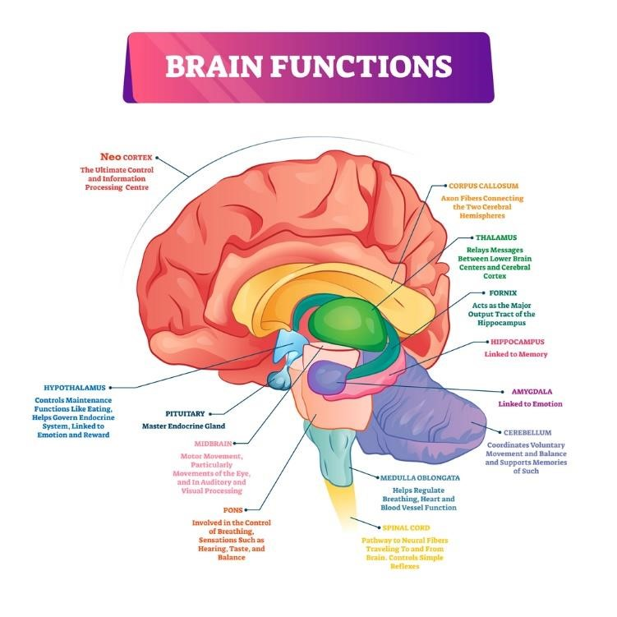
Fig.1 Memory sites in the brain
Memory can exist as short-term storage in the hippocampus and/or long term storage primarily in the neocortex (the outer regions of the brain — see Fig.1). Initiation of memory comes from sensory impulses (visual, auditory, kinesthetic, olfactory and gustatory) via the limbic system (hippocampus, cingulate cortex, olfactory cortex, and amygdala) and emotions from the hind brain. The hippocampus encodes these signals as episodic modules that are placed/embedded in the neocortex and other parts of the brain. Similar memory modules overlap each new module. Once this occurs the hippocampus no longer stores that memory. Instead it indexes it, so that if that memory is called for, it can be rapidly retrieved from the neocortex as vivid sensory and perceptual constructs. With repeated memory recall that original module is blended with the overlapping parts of similar modules. It is accurate but changed, recoded by the hippocampus and stored in the neocortex. Over time these blended memory modules can become strengthened and independent of the hippocampus (i.e. can operate directly out of the neocortex). With repeated recall these memory constructs lose their contextural richness and accuracy (decontextualised) and become more semantic (factual, lacking sensory and emotional impact) and often inaccurate. Yassa and Reagh suggest this is a continuum (see Fig.2)

Memory storage and retrieval
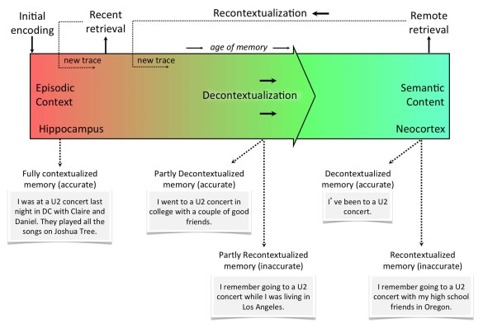
Fig.2. Memory storage and retrieval continuum Taken from Yassa and Reagh

Conclusion
Bandler and Grinder’s sensory mapping and linguistic communication modes, in a person under stress or affected by a recall of a previous stress or shock match da Vinci’s quote. Such a person would be one who
‘looks without seeing, listens without hearing, touches without feeling, eats without tasting, moves without physical awareness, inhales without awareness of odour or fragrance, and talks without thinking.’
Bandler and Grinder cracked the code and showed the world how to rectify the sensory anomalies, leading to better functioning.

The mediator as conductor part 4
Transactional Analysis
The fourth article in the ‘Mediator as a conductor’ series
Musical Connection: Transactional Analysis (TA) incorporates a number of triads of emotional and/or character traits, including the Parent, Adult and Child ego states. I have chosen Mozart's “trio divertimento for violin, cello and viola”, a beautiful piece, with the 3 instruments reminding me of the Father bear, Mother bear and Baby bear family and their interconnectedness.

The concepts embodied in Transactional Analysis are useful tools (musical repertoire) for a mediator. A mediator does not get into the treatment side of TA, she merely uses the information she observes and experiences within a meditation from a TA mindset, to help her understand where each mediatee is coming from. In turn, this process can mediate the mediator's thinking, language (verbal and non-verbal) and demeanor.
In the 1950’s, Eric Berne, a US Army psychiatrist treating Post World War 11 and Korean veterans with what nowadays would be called Post-Traumatic Stress Syndrome (PTSD), found Freudian psychiatry was time-consuming, ineffective, and poorly understood by the average person. Berne was an excellent listener, a compassionate doctor and a practical thinker. He developed a simple to teach and understand psychoanalysis therapy he called Transactional Analysis¹.
The starting points useful for mediators are:
- The Parent-Adult -Child (PAC) Ego States (Fig. 1)
- Games people Play²
- The Victim-Persecutor-Rescuer triad (developed by Karpman) ³
- The I’m OK - You're OK Life Positions or Corral (added later by Harris)⁴
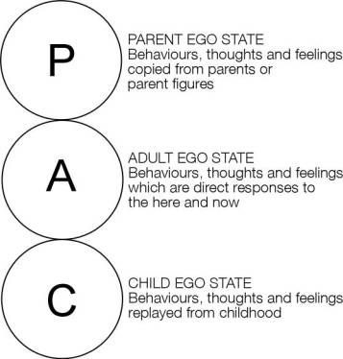
Fig. 1 PAC model
Berne observed that when people interact and begin speaking to each other, they would often switch from one state to another and this would embody a change in language, voice expressions and body language.
The Parent state contains all the
- instructions: “do this”, “don’t do that”, “you must …", “you should …" , this is the way you do it”.
- Commands: “No”, don’t”, “stop”, “do what I tell you”, “always vote Labour”, “work hard
- Rules: you can’t...”, “ always do ..” , "because I said so”
- Thoughts: “You’re good/bad/clumsy/useless/dumb/too smart/ “too shy”, “too noisy”
- Feelings “ I hate you”, I love you”, you are a scaredy-cat", “you are brave”, “you are always anxious”, “you make me angry/happy/sad”
that a non-verbal young child would hear, feel, react to, remember and recall at will, and at any age. These injunctions, both good and bad, are thought to be dominant in the first five years of age and are recorded (stored ) unedited as the “truth”. The associated verbal tone, inflection and volume plus the gestures, body positioning and facial expressions of the parental figure(s)are co-stored.
The Child state is created by the internalization of the "seeing and hearing and feeling and understanding" events in a child's early life. Harris paraphrases Aristotle : What is expressed is impressed" The “feeling" component predominates5. If a child is given a caring balanced parenting ( a nurturing parent) an “I’m OK" character trait will develop. “This Free Child (FC) reflects natural, loving, carefree, adventurous and trusting behaviours and is oblivious to the rules.”⁶ If the child is badly/poorly treated ( by a controlling or critical parent or a "pig parent”) then a I’m Not OK" character trait (a rebellious child or a adaptive/suppressed child) will develop.
The Adult state is balanced, rational, data acquiring-processing-storing, and is in constant contact with the Parent and the Child states. The Adult state is in the ‘now’, the present. The fully functioning Adult is acting out Aristotle’s “nous” and “practical thinking” and the Child and the Parent are but echoes of the past⁷.

Ego state | Typical words/phrases | Typical voice tone | Typical behaviour | Typical attitudes
Critical Parent (CP) | That is disgraceful. | Angry | Furrowed brow  Pointed finger  Pounding on table | Judgemental  Authoritarian
Nurturing Parent (NP) | I will sort it out for you. | Sympathetic | Consoling touch | Caring  Understanding
Adult (A) | When? | Calm  Enquiring | Relaxed  Attentive and aware  Level eye contact | Non-judgemental
Adapted Child (AC) | I will try hard.  Thank you. | Placating | Downcast eyes  Vigorous head nodding | Passive
Free Child (FC) | That is great. | Expressive | Clear demonstration of feelings | Spontaneous
Table 1: Examples of typical words, voice tones, behaviours and attitudes expressed by the differing ego-states during communication. Taken from Hollins Martin, C.J. (2011). Transactional Analysis (TA): a method of analysing communication. British Journal of Midwifery. 19(9): 587-593.

Often both mediatees will act out of different positions e.g. bully-boy ex-husband and sullen one-down Child position from the ex-wife. The aim of the mediator is to subtly via gesture, posture and “adult” language (I.e. conducting) shift both mediatees from an unbalanced Child or Parent state into a shared Adult state.

Games People Play
Berne observed that people will often play games when communicating( transacting) with another. By games he meant a two tiered dialogue with an innocuous message and a hidden often malicious or distorted lifeview message. He gave these games colloquial names like:
“Now I’ve got you, you son of a bitch”
“Poor me”
“Let’s you and him fight”
“Look how hard I’ve tried”
“Why don’t you, Yes, but”⁸

A common game played within a mediation is the “Now I’ve got you” game. Here one mediatee has overspent or is unable to repay for an item and becomes upset when sent a summons for payment. The plaintiff is painted as a ‘bad’/rotten person and is verbally attacked by the debtor mediatee for taking such a vicious, unfair court action. Anything the plaintiff says is disparaged, twisted or turned back onto the plaintiff. The debt is almost forgotten, side-tracked by the debtor’s verbiage and vilification. If the mediator or the plaintiff tries to focus on the debt, the debtor will often resort to a “poor me” game - too poor to pay because of Covid 19 or pension or Low study allowance or not enough to live on. The aim is to not have to pay anything, or at worst, pay a pittance on a protracted time payment scheme. The debtor will often shift from aggravated Critical Parent to wheedling Child mode.
The mediator’s task is to recognise the game and keep returning the dialogue to the debt and an obligation to repay. This often shifts to a “see you in court” game, usually as a bluff or in a misguided view that the Magistrate will believe his/her plight and perhaps even award damages for the stress generated. More work for the mediator in one-on-one sessions
The Karpman Drama triangle
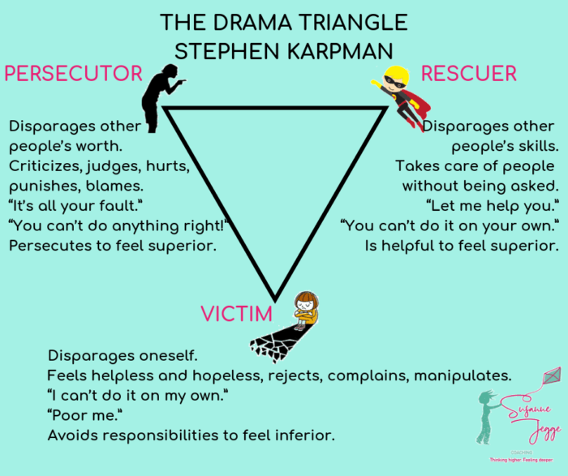
Fig.2. The Karplan Drama Triangle downloaded on 10/12/2020 from https://www.susannejegge.com/en/2019/05/29/drama-triangle-part-2/
Karplan’s drama triangle is often played out in mediation with mediatees shifting from one position to another. Power imbalance can lead to one of the mediatees being coerced into a victim role. At this point, the mediator can be sucked into the triangle often as the rescuer of the victim. The stage is for the victim to become the persecutor, and the persecutor becomes the victim. This can then lead to the victim, now persecutor, playing a “Lets you and him/her fight” game (between mediator and the other mediatee).

The Harris I’m OK You’re OK Life Choices
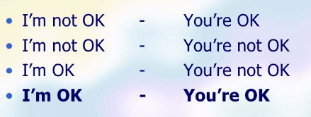
Fig. 3 Four Life Choices. Downloaded 10/12/2020 from https://www.slideshare.net/gangappalogged/im-ok-youre-ok-by-thomas-harris?next_slideshow=1
Thomas Harris, a co-worker with Berne, added to Berne’s modelling with his four Life Choices when comparing a person with any other person. The worst position is I’m not OK and You’re not OK. Any position on the left can be compared with any position on the right. The ultimate and best positions are I’m OK and You’re OK. This latter position may seem impossible at the start of mediation. However, with a preliminary warning that mediation is not about winning, nor getting everything, rather, it is about a “walk-away” solution, both mediatees can walk away feeling “OK”.
Conclusion
A knowledge of the basic components of TA, within a mediator’s repertoire, will enhance the listening, observational and communication skills that, in turn, can achieve a desired settlement. Articles, books and slide shows on TA are readily available, online. TA is an easy concept to understand and use within mediation, without conducting any psychotherapy.

The mediator as conductor Part 5
Emotional intelligence
The fifth article in the ‘Mediator as a conductor’ series
David Mitchell

Musical connection: Emotional Intelligence (EQ) in a figure such as a leader, a conductor or a mediator both leads and shares, and inspires an interaction with others. At a certain point there is a consensus (entrainment) and a positive mood/flow occurs. This is often called the Aha! moment in mediation. I am grateful to Tasmanian mediator, Gail Cork who suggested this symphony as a ‘stunning example of emotional intelligence in the form of restraint and perfect timing can be found in Symphony No 3 in C Minor by Camille Saint-Saëns. Although it's known as the Organ Symphony, the organ is scarcely heard until 28 minutes into the 36 minute work. When it finally arrives, it does so with a crashing sustained C Major chord which heralds a dramatic shift and brings the entire orchestra in behind it for the final movement”. Watch this happen on YouTube.

Emotional Intelligence
The effective negotiator or mediator must take into account not only the economic, political and physical aspects of the process, but also the emotional tenor of themselves as well as that of all of the parties.
The 1970s and 1980s heralded a ‘New Age’ that rebelled at the post World War II rationality and hard work ethic in favour of spirituality, autonomy and psychology. This generated a plethora of books on self-help, get rich quick schemes, and business success theories and ideas. A notable success was Daniel Goleman’s concepts contained in his 1985 book Emotional Intelligence. Goleman, an astute observer with an inquiring mind, promoted the idea that humans were controlled by their emotions, often swamping rational thinking and behaviour. Those people who could control their emotions possessed ‘emotional intelligence’(EQ) and were more successful in life and in business. Moreover, by following his model, EQ could be enhanced, and those who displayed lower EQ, could learn (and be taught) how to become more emotionally intelligent. Successful business leaders and entrepreneurs were considered to have high EQ and courses in EQ became, and often, still are, mandatory for those seeking advancement or promotion.
Mediation, emerging from a judicial ethos with its rigid adherence to reason and logic, was slow to adopt EQ concepts. Fisher and Uly’s 1983 seminal book on mediation advised the mediator to ‘separate the people from the problem’. Similarly, Jones (1999) called mediation an ‘emotion-free zone’. Schreier’s report on mediation training’s neglect of emotion was one of many at the turn of the century to propose teaching mediators emotion training including EQ. Kelly more recently published a very readable paper with some caveats for mediators considering EQ.

Concepts of EQ
Emotional Intelligence (EQ) was first defined by Salovey and Mayer as, ‘… the ability to monitor one’s own and others’ feelings and emotions, to discriminate among them and to use this information to guide one’s thinking and actions’ . Goleman defined EQ as ‘the capacity for recognising our own feelings and those of others, for motivating ourselves, and for managing emotions well in ourselves and others’.
Whilst Goleman’s book made him the ‘unofficial’ expert on EQ, he had borrowed heavily from Salovey and Mayer’s (1990) work on EQ and Boyatzis’ (1982) work on competencies. Salovey and his co-workers continue to publish on EQ. Both have their models of EQ and, progressively, the business market has added their own interpretations such that currently the consensus model is number 3.0 (Emotional and Social Competency Inventory (ESCI).
Goleman considered that there were four (originally five) main categories (he called them ‘clusters’) that covered a series of skills or competencies that collectively measured EQ. The 25 foundation competencies have been shaved down to twelve.
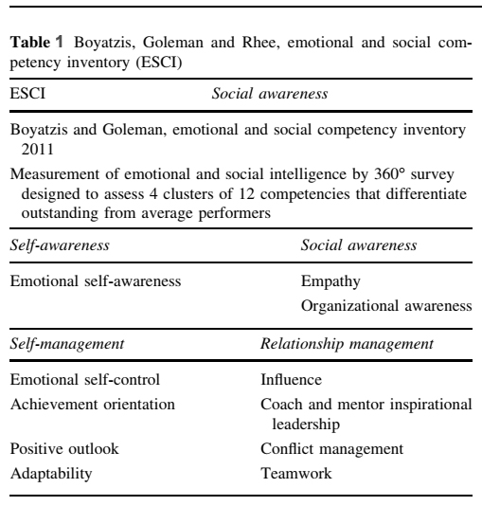
Downloaded from Segon and Booth. DOI 10.1007/s10551-013-2029-z
Self-awareness and self-management deal with the inner ‘self’, and social-awareness and relationship management deal with the external ‘others’. Most experts consider that a good manager does not have to have high EQ levels in all competencies.
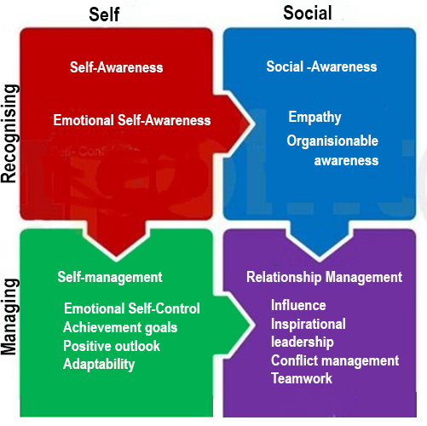
Fig.1. Alternative model for EQ adapted from Goleman. Emotional Intelligence,
showing the relationships between clusters and their allocated competencies.

Delphic tablet inscribed ‘Know Thyself’
(Self-awareness)
Self-awareness is the ability to know and understand the ‘real self’: strengths and weaknesses; beliefs and values; habits and actions; virtues and vices. Knowing these areas that generate positive or negative emotions allows a person (e.g. a mediator) to take control and manage their emotions which is part of the self-management realm (cluster).
A quote attributed to Sun Tzu says, ‘If you know the enemy and know yourself, you need not fear the result of a hundred battles.’
Sun Tzu’s word, the 'enemy’ could just as easily be changed to any other person, transaction, interaction or dialogue with another.
Thus, being able to recognise, identify and understand others’ emotions, narratives and worldview (social-awareness) can help a mediator better interact with, and manage relationships with, others (relationship management).
Learning EQ
- Self-awareness
Training to understand and manage strong emotions helps a mediator
(1) build tolerance for expression of emotion,
(2) develop detachment and reduce stress,
(3) inculcate patience and humility, and
(4) promote a realistic understanding of outcomes .
Feedback in Scheirer’s research on mediator training in EQ deduced that EQ is ‘part talent, part gift, part personality, part experience, part training.... but most of it is life experience. You can’t just act like a mediator; you must live your life that way’
Bowling and Hoffman (2000) suggest that persistent reflective experience, discipline, and intention, more than intellectual inquiry, are needed to learn optimal self-awareness. They refer to meditation, yoga, religious discipline, and psychological inquiry as useful practices to assist a mediator in developing authentic presence; integration of mind, body, and emotions; and a higher level of self-awareness.
It is pertinent to note that an authentic leader has many of the same attributes as a high rated EQ manager/leader (See Fig.2). In turn there is a correlation between both in Aristotle's concept of a good person. To paraphrase Aristotle: ‘In the right hands, with the right person, at the right time and for the right reasons, a good mediator will create a positive result from a mediation.’
Thus, learning EQ revolves around continuing self-education in some of the following:
  - Reflective training and consistency in use
  - Mindfulness, compassionate meditation, loving kindness meditation
  - Adherence to Aristotle’s virtue ethics and practical wisdom
  - EQ assessment questionnaires/profile. Whilst none are completely accurate, they can be used as a form of ongoing assessment of learning
  - EQ leadership courses or seminars. These are high on rhetoric and low on practical information, yet can suit some individuals
  - Seminars or publications on Authentic Leadership
  - Wellness programs including diet, nutrition, exercise, yoga and sleep cycles
  - Association with like-minded peers, mentors, supervisors and external contacts
  - Read, absorb and share
  - Add appropriate music to a daily regimen

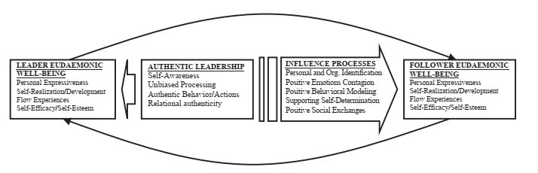
Fig.2 Authentic leadership, EQ and qualities of a ’good person.
Downloaded from https://doi.org/10.1016/j.leaqua.2005.03.002

The downside of EQ
1. Negative effects of empathy
Humans can react positively to another’s pain or distress in one of three ways:
  - Sympathy defined as feeling a person’s distress and absorbing it so they feel better. Yet the sympathiser now carries those emotions.
  - Empathy defined as caring so much for a person’s distress so as to want to feel their emotional distress as a means of understanding. This is often referred as ‘walking in another person’s shoes for a day’. This can lead to empathy contagion wherein the emotions of the distressed person can contaminate the mediator, affecting their judgement or, conversely, the emotions of the mediator can contaminate the distressed mediatee. A mediator who is not sufficiently self-aware can, over time, develop empathy distress/overload and function at lower and lower levels of competency.
  - Compassion (sometimes called mature empathy or empathic compassion) is defined as ‘the emotional perception and recognition of the suffering of others and the desire to alleviate it, understanding the universality of suffering, feeling moved by the person suffering and emotionally connecting with their distress, and tolerating uncomfortable feelings (e.g., fear, distress) so that we remain open to and accepting of the person suffering.’
The two main differences from empathy are not taking on the person’s distress/emotions (thus avoiding empathy contagion and empathic overload) and secondly, the desire to do something about it. It is the drive to do something for the ‘distressed’ person that makes compassion superior to, and safer than, empathy. To be compassionate and show compassion requires a state of self-compassion, a learnt behaviour.
Klimecki, Leiberg, Ricard, and Singer have shown that empathy stimulates different areas in the brain compared with compassion and that the empathy signals were negative compared to the compassion signals.
Svenaeus makes a strong case for mature empathy (i.e. compassion) being an essential part of Aristotle’s phronesis or practical wisdom which increases a mediator‘s chances of achieving a good outcome.

2.EQ has removed ethics from its competencies
The gradual shift in EQ towards managerial behaviour and a focus on results at any cost has led to the removal of any ethical competency in the various iterations of EQ. More and more managers and leaders are referred to as high EQ performers yet many are resorting to unethical behaviour such as using empathy and perceived trustworthiness and authenticity to unduly influence their workforce. Segon and Booth have put forward a newer model for EQ that re-establishes ethics as an integral part of an authentic EQ leader. Given the increasing numbers of high profile or high flyer CEOs and managers who have been exposed as criminals (think Enron or Ponzi schemes) this new EQ competency chart is timely. See Fig.3.

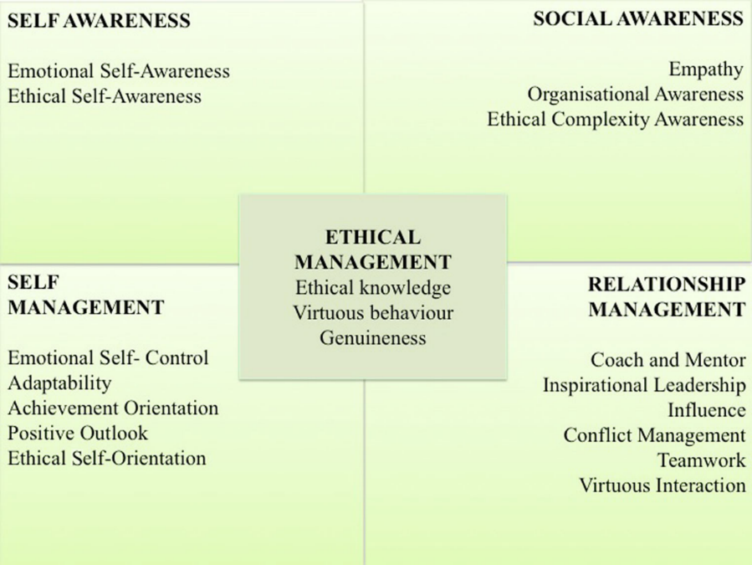
Fig.3. Segon & Booth:A proposed exemplar of an ethically informed ESCI framework with Ethics as a foundation competency. Downloaded from DOI 10.1007/s10551-
Conclusion
EQ is a difficult instrument to learn and play. It is person-centered, not work/skill centered. Self-compassion leads to compassion for others and onto practical wisdom and appropriate action. A good, experienced mediator as conductor with innate and acquired EQ can use it within himself/herself and achieve the greater good for the mediatees.

The mediator as conductor: Part 6
Compassion and Self-compassion
The sixth article in the ‘Mediator as a conductor’ series
David Mitchell
Musical connection. Compassion invokes a feeling for the suffering of another/others and a desire to do something about it. Compassionate music must be sad, soulful and transcend the norm and take us someplace else. . Of the multiple choices I selected four beautiful pieces: Simon & Garfunkel’s “Bridge over Troubled Waters”. Stephen Oliver’s “Lament for the Fallen”, Jan Gabarek and the Hillard Ensemble’s “Officium” and Andrew Lloyd Weber’s Requiem. The winner is: Sarah Brightman and Paul Miles-Kingston singing Lloyd Weber’s “Pie Jesu” from his Requiem.
Compassion and its place in a Mediator
“Compassion is perhaps one of the most basic virtues that might be expected of mediators.”
Compassion is slowly emerging from the empathy-induced mists of obfuscation by empathy studies to become a signification factor in health and happiness in human beings.
Compassion toward others has been associated with both cognitive and affective empathy, the healing of emotional pain, acceptance toward self
and others, decreased negative affect, and greater forgiveness .
This paper will show how compassion develops from an autonomous decision to practise self-compassion, transcends empathy, and becomes an integral part of Aristotle’s Practical Wisdom . Such a combination is an ideal fit for the emotional, and intellectual traits and persona of a mediator.

Definitions of Sympathy, Empathy and Compassion
- is an emotional reaction of pity toward the misfortune/pain/distress of another.
2 . Empathy is often divided into two or more types
a. Affective empathy, where a person experiences another’s emotions.
b. Cognitive empathy where a person tries to imagine and understand what it would be like to be in another’s shoes. This is a more detached, intellectual exercise and any action is conditional on multiple negative factors.
3. “Compassion has been described as a special form of empathy
that involves not only having feelings of concern for the suffering of others but
also wanting to alleviate it” (Siegel & Germer).
Mascaro et al define compassion, “as the deep wish that another be free from suffering, coupled with the motivation to alleviate such suffering “
The biggest difference between compassion and empathy is the compassionate desire to act or move to alleviate the suffering (or pain, stress, emotional distress, etc) of a person.
The second difference is that empathy can cause mediators to mix their emotions with those of a mediatee (contamination) or be overwhelmed by an accumulation of emotions from ongoing mediation and experience fatigue or exhaustion/burn-out. This does not happen with compassion work.
The Buddhist Connection

Sinclair et al summarise” the relationship between these three constructs from a Buddhist perspective, conceptualizing sympathy as an emotional reaction, without conscious thought and reflection. Empathy is understood as a more complex interpersonal construct that involves awareness and intuition, while compassion is defined as “a way to develop the kindness, support, and encouragement to promote the courage we need—to take the actions we need—in order to promote
the flourishing and well-being of ourselves and others”
Origins of Empathy
Psychologist and Primatologist, Frans De Waal postulates that empathy is a primal state or core element of social attraction, cooperation and imitation. This core self is unconscious .Like a Russian Doll, there is a secondary layer with a tendency for concern and consolation for another in distress and an outer or third layer of cognitive, selective perception and judgement as to the level or depth of concern (PAM or Russian Doll model hypothesis by de Waal), see Fig.1.
The core element is analogous to Ricoeur’s core “self” and the next two layers are part of Ricoeur’s “self as another” , facsimiles or part representation of the core self cloaked in the persona of a person appropriate for that situation, event, or interaction.
… a “narrative identity.” that can contain and articulate a flux of contradictory selves and their mutability within one same person/literary character in a lifetime, or in
certain periods of time.
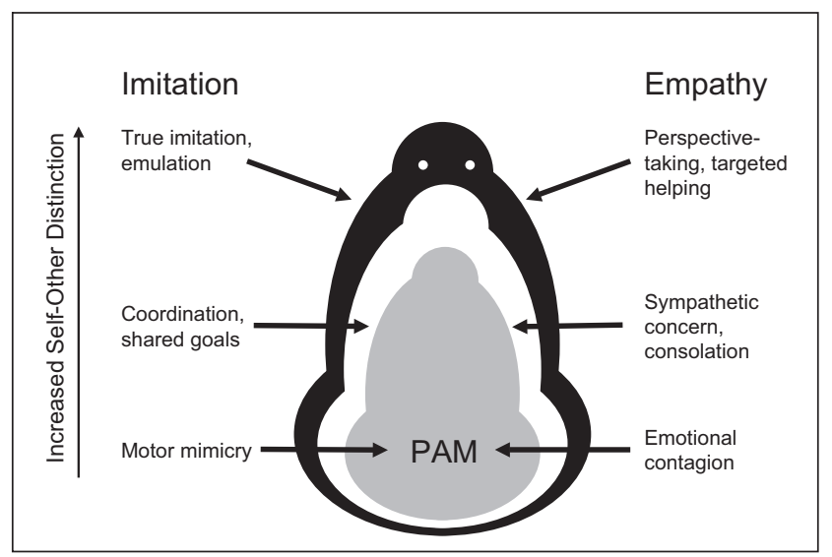.
Fig.1.The PAM hypothesis. Adapted from de Waal doi:10.1146/annurev.psych.59.103006.093625.

Origins of Compassion :
Three distinct evolutionary lines for the development and presence of compassion were summarised in Goetz et al:
1. The vulnerable offspring argument: “compassion is thought to have emerged as the affective element of a caregiving system, designed to help raise vulnerable offspring to the age of viability (thus ensuring that genes are more likely to be replicated)”.
2. Sexual Selection theory: “More inclined to feel compassion during times of others' need and suffering, compassionate reproductive partners should be more likely to devote more resources to offspring, to provide physical care—protection, affection, and touch—and to create cooperative, caring communities so vital to the survival of offspring”.
3. The pro-social assumption: that compassion “evolved within a complex system of emotional states—involving liking, gratitude, anger, and guilt—which enable non-kin to initiate, maintain, and regulate reciprocally altruistic relationships”.
Compassion has always been a force in Buddhism as one of the four immeasureables :
loving-kindness or benevolence
compassion
empathetic joy
equanimity

Neurological differences between Compassion and Empathy.
fMRI studies clearly show compassion and empathy activate different areas of the brain.
empathy engages a network of brain areas centered around the anterior
insula and anterior midcingulate cortex, areas associated with negative affect, compassionate states have been associated with activity in the medial orbitofrontal cortex and ventral striatum, and come with feelings of warmth, concern, and positive affect.
Chierchia & Singer in refashioning de Waal’s PAM found that the unconscious and automatic traits of emotional contagion and mimicry followed different pathways and affects. In a compassionate person (a feeling for others) an empathic event would generate positive brain signals and a desire to help. Where the event was stressful, in the absence of compassion, the feeling with others would generate distress, withdrawal and self-centred behaviour. See Fig.2

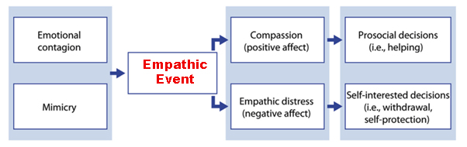Fig.2 The relationship between frequent precursors and possible consequences of empathy. Adapted from Chierchia & Singer

Benefits of Compassion for Mediators

Kristen Neff a world expert on Compassion and self-compassion has documented a number of significant benefits from actively engaging in self-compassion and compassion (taken from Neff 2003,2005,2007,2008)
- greater emotional resilience and psychological well-being
- less anxiety and depression
- increased self-esteem
- happier
- is strongly associated with emotional intelligence and Practical Wisdom.
- greater connectedness to others
- Less afraid of failure
- more intrinsically motivated to learn and grow.
- connections to Emotional Intelligence and Aristotle’s Practical Wisdom

The Development of Compassion
Compassion begins with self-compassion. To know oneself, to understand one’s virtues and faults, to forgive oneself for any faults in thinking, for failures in behaviour and performance are essential before one can express compassion for another.
Extending compassion to the self, self-compassion, refers to a regulation strategy in which feelings of worry or stress are not avoided but instead being open and sensitive to one's own suffering, experiencing feelings of care and kindness to oneself, taking an attitude of understanding and not judging one's own inadequacies and failures, and recognizing that one's own experience is part of the common human experience (Neff, 2003).
1) extending kindness and understanding to oneself rather than harsh self-criticism and judgement.
2) seeing one’s experiences as part of the larger human experience rather than as separating and isolating.
3) holding one’s painful thoughts and feelings in balanced awareness rather than over-identifying with them.

Fig.3 Neff’s three basic components of self-compassion
Self-compassion is neither self-centeredness, selfishness nor narcissism. An open-mindedness and acceptance for oneself allows a similar (compassionate) approach to others, without corruption, contagion distress, judgement, or distortion of another’s reality (e.g., in a mediation). See fig.4.
Self Esteem
Self-Compassion
Compassion
Decision to become compassionate.

Fig.4. Author’s concept of self-self-compassion-compassion Stage 1
Self Esteem
Self-Compassion
Compassion
Decision to become compassionate.
Following a decision to engage in self-compassion, leading to compassion for others, one needs a mechanism, technique, or practice . Mindfulness provides such a methodology.
. Mindfulness is a nonjudgmental, receptive mind state in which individuals observe their thoughts and feelings as they arise without trying to change them or push them away, but without running away with them either”
Mindfulness

Mindfulness

Fig.5 Author’s concept of self-self-compassion-compassion Stage 2
There is an abundance of articles, books, courses, and web sites, on mindfulness. It is easy to learn and becomes almost automatic with habituation.
Separately the Buddhist practise of Loving Kindness can achieve equivalence So too can compassion - meditation courses .
Compassion and music
One of the beguiling discoveries within compassion research has been the connection with music. In particular, ‘sad’ music.
Huon and Vuoskoski’s Pleasurable Compassion Theory suggests that one who has a compassionate trait/nature/tendency is more likely to “be moved” by such music and experience a positive or pleasurable state. This compassionate pleasure is ” typically subliminal, unconscious, and cognitively opaque”.
Further reading can be found in Wallmark et al’s review
This may partly explain why my choices of music matching this article was difficult to narrow down to one piece. I liked them all. It may well be that this musical-compassion state can be used as a compassion meter. The more one’s compassion (or progress in compassion training), the more the attraction to, and pleasure from, sad music. Alternatively, Neff has produced a workable Self-Compassion questionnaire.
Conclusion
Compassion is innate and part of human socialisation, interaction, and preservation. A mediator can utilise it personally and in mediation. It is safe, ethical, effective, self-protective and health-making. It can be taught and learnt. A fitting part of a mediator’s (as a conductor) repertoire.
David Mitchell

Sylvie Nozaradan S. 2014 Exploring how musical rhythm entrains brain activity with electroencephalogram frequency-tagging. Phil. Trans. R. Soc. B 369: 20130393. http://dx.doi.org/10.1098/rstb.2013.0393 Definition: Entrainment to music is an extremely common behaviour, shared by humans of all cultures. It is a highly complex activity, which involves auditory, and also visual, proprioceptive and vestibular perception.
Kumar AB and Morrison SJ (2016) The Conductor as Visual Guide: Gesture and Perception of Musical Content. Front. Psychol. 7:1049. doi: 10.3389/fpsyg.2016.01049
Dena Schecthter 2009. Mediation Music downloaded from www.mediate.com/articles/schechterD2.cfm
Schecthter ibid
Eveline Geiser, Kerry Walker, Danie Bendorl 2014. Global timing: a conceptual framework to investigate the neural basis of rhythm perception in humans and non-human species. Frontiers in Psychology, VOLUME 5, 2014 . https://doi.org/10.3389/fpsyg.2014.00159
Jessica A. Grahn 2012. Neural Mechanisms of Rhythm Perception: Current Findings and Future Perspectives. Topics in Cognitive Science 4 (2012) 585–606 DOI: 10.1111/j.1756-8765.2012.01213.x
Nozaradan ibid1
Kumar and Morrison ibid¹
Brian A. Silvey and Christopher M. Baumgartner. Undergraduate Conductors’ and Conducting Teachers’ Perceptions of Basic Conducting Efficacy. DOI: 10.1177/8755123314554809
Kumar ibid1
Kumar ibid ¹
Karen Allendoerfer Neuroscientist and violinist at https://www.violinist.com/discussion/archive/12240/ Classical Music in Film.
Pedro Santos Boia, « Antoine Hennion, The Passion for Music: A Sociology of Mediation », Transposition [Online], 6 | 2016, Online since 20 March 2017, connection on 31 July 2019. URL : http://journals.openedition.org/transposition/1473
Barbara Hardy,1968,p.5., quoted in Bernard Williams.2007. Life as Narrative. European Journal of Philosophy 17:2 ISSN 0966-8373 pp. 305–314 DOI: 10.1111/j.1468-0378.2007.00275.x
Bernard Williams 2007 Life as Narrative. European Journal of Philosophy 17:2 ISSN 0966-8373 pp. 305–314 DOI: 10.1111/j.1468-0378.2007.00275.x.
Oliver Sachs. 1985 Sacks, Oliver (1985). The man who mistook his wife for a hat, and other clinical tales. New York: Summit.
Oliver Sachs Ibid ³
Veronica Ellis. 2007. The Narrative Matrix and Wordless Narrations: A Research Note. Augmentative and Alternative Communication, June 2007 VOL. 23 (2), pp. 113 – 125 DOI: 10.1080/07434610600931858
5⁵ Henry Venema. Paul Ricoeur of Refigurative Reading and Narrative Identity Symposium. Volume 4, Issue 2, Fall 2000. Pg. 237-248 https://doi.org/10.5840/symposium20004219
An utterance is ‘the movement of bonding two or more positioning acts, so that the discursive field in which a given position have been taken becomes reorganised. It is a dynamic process.’ Andrés Haye and Antonia Larraín. 2011.WHAT IS AN UTTERANCE? Dialogicality in Focus ISBN 978-1-61122-817-5. Editors: M. Märtsin, B. Wagoner et al. pp. © 2011 Nova Science Publishers,Inc. Downloaded from : https://www.researchgate.net/publication/229433006_What_is_an_utterance/link/5c87ad5c92851c831974dc6d/download
See ⁷
Alison Cotter 2012a. A Narrative Approach to Employment mediation. Explorations: An e-journal of narrative practice | www.dulwichcentre.com.au/e-journal.html | 2012 Issue 1, 1-3.
Ruth Beach, 2019, Resolution Institute PDG event | Mediation and the grieving process, Thursday 31 October 2019 | Adelaide.
Winslade, J. & Monk, G. (2008). Practicing narrative mediation: Loosening the grip of conflict. San Francisco, CA: Jossey Bass.
Debbie Dunn, Tasmanian mediator in Resolution Institute webinar - Narrative Mediation. What’s the story?, June 2020.
Cotter See⁹
Cotter Ibid
Cotter See ⁹
Winslade and Monk See ¹¹
C Adam Foster Once upon a Mediation: The role of Narrative in ADR. Colorado Lawyer April 2019
The Notebooks of Leonardo da Vinci- Complete. Project Gutenberg Ebook 2004 Translated by Jean Paul Richter 1888. Downloaded: http://www.gutenberg.org/ebooks/5000
Norman Cowan. The magical number 4 in short-term memory: a reconsideration of mental storage capacity. Behav Brain Sci. 2001 Feb;24(1):87-114; discussion 114-85. doi: 10.1017/s0140525x01003922. PMID: 11515286.
George Miller. The magical number seven, plus or minus two: some limits on our capacity for processing information. 1956. Psychol Rev. 1994 Apr;101(2):343-52. doi: 10.1037/0033295x.101.2.343. PMID: 8022966.
Richard Bandler and John Grinder Structure of Magic Vol.1 & 2
Russell W. Chan, Alex T. L. Leong, Leon C. Ho, Patrick P. Gao, Eddie C. Wong, Celia M. Dong, Xunda Wang, Jufang He, Ying-Shing Chan, Lee Wei Lim, Ed X. Wu . Hippocampus drives functional connectivity. Proceedings of the National Academy of Sciences Aug 2017, 114 (33) E6972-E6981; DOI: 10.1073/pnas.1703309114
Michael A.Yassa and Zachariah M. Reagh Competitive trace theory: a role for the hippocampus in contextual interference during retrieval. Frontiers in Behavioral Neuroscience. August 2013 | Volume 7, Article 107 doi: 10.3389/fnbeh.2013.00107
Michael A.Yassa and Zachariah M. Reagh Competitive trace theory: a role for the hippocampus in contextual interference during retrieval. Frontiers in Behavioral Neuroscience. August 2013 | Volume 7, Article 107 doi: 10.3389/fnbeh.2013.00107
Rubin Alaie. Representational systems: is someone visual, auditory or kinesthetic?. Downloaded 22/11/2020 from https://happyrubin.com/nlp/representational-systems/
Rubin Alaie. NLP Predicates – The best examples [Lists with words] Downloaded 22/11/2020 from https://happyrubin.com/nlp/predicates
Paul Rhodes 2016. Paul Ricoeur and Narrative Identity. Why we are our story . Psychology Today. ricoeur-and-narrative-identity Downloaded 22/11/2020 from https://www.psychologytoday.com/au/blog/post-clinical/201604/paul-
Wim Pouw, James A. Dixon.2019 Entrainment and Modulation of Gesture–Speech Synchrony Under Delayed Auditory Feedback. Cognitive Science 43 (2019) e12721 DOI: 10.1111/cogs.12721
Joseph O’Connor. NLP workbook 2001. The practical guidebook to achieving the results you want. Thorsons Publishers UK. Downloaded22/11/2020 from https://doc.lagout.org/science/0_Computer%20Science/3_Theory/Neural%20Networks/Neuro%20Lin guistic%20Programming%20WorkBook.pdf
Russell W. Chan, Alex T. L. Leong, Leon C. Ho, Patrick P. Gao, Eddie C. Wong, Celia M. Dong, Xunda Wang, Jufang He, Ying-Shing Chan, Lee Wei Lim, and Ed X. Wu. Low-frequency hippocampal–cortical activity drives brain-wide resting-state functional MRI connectivity. PNAS August 15, 2017 114 (33) E6972-E6981; first published July 31, 2017; https://doi.org/10.1073/pnas.1703309114
Michael Yassa, Zachariah Reagh . 2013. Competitive Trace Theory: A Role for the Hippocampus in Contextual Interference during Retrieval .Frontiers in Behavioral Neuroscience Vol7 . Downloaded 21/11/2020 from: https://www.frontiersin.org/article/10.3389/fnbeh.2013.00107. DOI=10.3389/fnbeh.2013.00107
Yassa & Reagh Ibid
https://www.youtube.com/watch?v=ZWCZq33BrOo
Edward J. Kelly and Natalija Kaminskiene. 2016. Importance of emotional intelligence in negotiation and mediation. International Comparative Jurisprudence 2 (2016) 55-60. http://dx.doi.Org/10.1016/j.icj.2016.07.001
R. Fisher, W. Ury. 1983. Getting to yes: negotiating agreement without giving in. Penguin Books, New York .
Schreier, L. S. (2002). Emotional intelligence and mediation training. Conflict Resolution Quarterly, 20(1), 99–119. doi:10.1002/crq.13 quoting Jones, T., and Bodtker, A. Mediating with Heart in Mind Communication Insights on Mediation Process and Training: The Role of Emotion. Community Outreach Workshop, International Communication Association Conference, San Francisco, May 1999 .
Schreier. ibid
Kelly ibid ²
Salovey, P., & Mayer, J. D. (1990). Emotional intelligence. Imagination, Cognition and Personality, 9, 185–211.
Salovey, P., & Mayer, J. D. (1990). Emotional intelligence. Imagination, Cognition and Personality, 9, 185–211.
Segon, M., Booth, C. Virtue: The Missing Ethics Element in Emotional Intelligence. J Bus Ethics 128, 789–802 (2015). https://doi.org/10.1007/s10551-013-2029-z
Segon, M., Booth, C. ibid ⁹
Segon and Booth. ibid
Schrerier ibid⁵
Schreier ibid⁵
Schrerier ibid⁵ quoting Bowling, D., and Hoffman, D. “Bringing Peace into the Room: The Personal Qualities of the Mediator and Their Impact on the Mediation.” Negotiation Journal,Jan. 2000,pp. 5-28.
Remus Ilies, Frederick P. Morgeson, Jennifer D. Nahrgang, 2005. Authentic leadership and eudaemonic well-being: Understanding leader–follower outcomes, The Leadership Quarterly, Volume 16, Issue 3, 2005,
Annamaria Di Fabio and Donald H. Saklofske, Personality and Individual Differences, https://doi.org/10.1016/j.paid.2020.110109
Olga M. Klimecki,Susanne Leiberg,Matthieu Ricard,and Tania Singer. 2014 Differential pattern of functional brain plasticity after compassion and empathy training. doi:10.1093/scan/nst060 SCAN (2014) 9, 873^87 .
Fredrik Svenaeus. 2014. Empathy as a necessary condition of phronesis: a line of thought for medical ethics. Med Health Care and Philos (2014) 17:293–299. DOI 10.1007/s11019-013-9487-z .
Segon and Booth ibid ¹⁰
Barbara Wilson: In Search of Family Mediation Virtue Ethics: Picking Through the Undergrowth (September 25, 2018). Available at SSRN: https://ssrn.com/abstract=3391754 or http://dx.doi.org/10.2139/ssrn.3391754
Cheryl L Fulton. Self-Compassion as a Mediator of Mindfulness and Compassion for . April 2018. Counselling and Values 63(1):45-56. DOI: 10.1002/cvj.12072
Fulton ² above
Svenaeus F. Empathy as a necessary condition of phronesis: a line of thought for medical ethics. Med Health Care Philos. 2014 May;17(2):293-9. doi: 10.1007/s11019-013-9487-z. PMID: 24687325. Note: Svenaeus postulates that a higher form of empathy is the feeling part of Phronesis and Phronesis is the deliberative and action agent equating to compassion
Siegel & Germer, 2012 quoted in Fulton² above.
Mascaro Jennifer S., Darcher Alana, Negi Lobsang T., Raison Charles L. The neural mediators of kindness-based meditation: a theoretical model. Frontiers in Psychology Vol 6,2015 Doi:10.3389/fpsyg.2015.00109
Sinclair S, Beamer K, Hack TF, McClement S, Raffin Bouchal S, Chochinov HM, Hagen NA. Sympathy, empathy, and compassion: A grounded theory study of palliative care patients' understandings, experiences, and preferences. Palliat Med. 2017 May;31(5):437-447. doi: 10.1177/0269216316663499. Epub 2016 Aug 17. PMID: 27535319; PMCID: PMC5405806.
De Waal, F. B. M. (2008). Putting the Altruism Back into Altruism: The Evolution of Empathy. Annual Review of Psychology, 59(1), 279–300. doi:10.1146/annurev.psych.59.103006.093625
„Zorica Bečanović-Nikolić “Oneself as Another“ and „Narrative Identity“ in Shakespeare and Montaigne. Downloaded from https://www.ceeol.com/search/article-detail?id=528246. 16/02/2021
De Waal⁶ above
Goetz JL, Keltner D, Simon-Thomas E. Compassion: an evolutionary analysis and empirical review. Psychol Bull. 2010 May;136(3):351-74. doi: 10.1037/a0018807. PMID: 20438142; PMCID: PMC2864937.
Fulton C. 2018 Self-Compassion as a Mediator of Mindfulness and Compassion for Others. counselling and Values ■ April 2018 ■ Volume 63. P. 45-56
(Chierchia, G., & Singer, T (2017). The Neuroscience of Compassion and Empathy and Their Link to Prosocial Motivation and Behaviours. Decision Neuroscience, 247–257. doi:10.1016/b978-0-12-805308-9.00020-8
Chierchia, G., & Singer, T (2017). The Neuroscience of Compassion and Empathy and Their Link to Prosocial Motivation and Behavior. Decision Neuroscience, 247–257. doi:10.1016/b978-0-12-805308-9.00020-8
Chierchia, G., & Singer, T ⁸ above
Neff, K. D. (2003). The development and validation of a scale to measure self-compassion. Self and Identity, 2, 223–250.Neff, K. D., Hseih, Y., & Dejitthirat, K. (2005). Self-compassion, achievement goals, and coping with academic failure. Self and Identity, 4, 263-287. Neff, K. D., Kirkpatrick, K. & Rude, S. S. (2007). Self-compassion and its link to adaptive psychological functioning. Journal of Research in Personality, 41, 139-154.Neff, K. D., Pisitsungkagarn, K., & Hseih, Y. (2008). Self-compassion and self-construal in the United States, Thailand, and Taiwan. Journal of Cross-Cultural Psychology, 39, 267–285.Neff, K. D. & McGeehee, P. (2010). Self-compassion and psychological resilience among adolescents and young adults. Self and Identity, 9, 225-240.Neff, K.D. (2009). Self-Compassion. In M.R. Leary & R.H. Hoyle (Eds.), Handbook of individual differences in social behavior (pp. 561–573) . New York: Guilford Press.
Neff, K. D. (2003). Self-Compassion: An Alternative Conceptualization of a Healthy Attitude Toward Oneself. Self and Identity, 2(2), 85–101. https://doi.org/10.1080/15298860309032
Neff¹⁷ above
Neff¹⁷ ibid
Huron David, Vuoskoski Jonna K. On the Enjoyment of Sad Music: Pleasurable Compassion Theory and the Role of Trait Empathy Frontiers in Psychology 11 2020. DOI=10.3389/fpsyg.2020.01060
Huron ²⁰ above
Wallmark Zachary, Deblieck Choi, Iacoboni Marc. Neurophysiological Effects of Trait Empathy in Music Listening. Frontiers in Behavioral Neuroscience 12.2018. DOI=10.3389/fnbeh.2018.
Neff Self-compassion scale download from https://self-compassion.org/self-compassion-scales-for-researchers/

