The mediator as conductor
Transactional Analysis
The fourth in the Mediator as Conductor series
Musical connection: Transactional Analysis (TA) incorporates a number of triads of emotional and/or character traits, including the Parent, Adult and Child ego states. I have chosen Mozart's “trio divertimento for violin, cello and viola”, a beautiful piece, with the 3 instruments reminding me of the Father bear, Mother bear and Baby bear family and their interconnectedness.

The concepts embodied in Transactional Analysis are useful tools (musical repertoire) for a mediator. A mediator does not get into the treatment side of TA, she merely uses the information she observes and experiences within a meditation from a TA mindset, to help her understand where each mediatee is coming from. In turn, this process can mediate the mediator's thinking, language (verbal and non-verbal) and demeanor.
In the 1950’s, Eric Berne, a US Army psychiatrist treating Post World War 11 and Korean veterans suffering from what nowadays would be called Post-Traumatic Stress Syndrome (PTSD), found Freudian psychiatry was time-consuming, ineffective, and poorly understood by the average patient. Berne was an excellent listener, a compassionate doctor and a practical thinker. He developed a simple to teach and understand psychoanalysis therapy he called Transactional Analysis.
The starting points useful for mediators are:
- The Parent-Adult -Child (PAC) Ego States (Fig. 1)
- Games people Play
- The Victim-Persecutor-Rescuer triad (developed by Karpman)
- The I’m OK - You're OK Life Positions or Corral (added later by Harris)
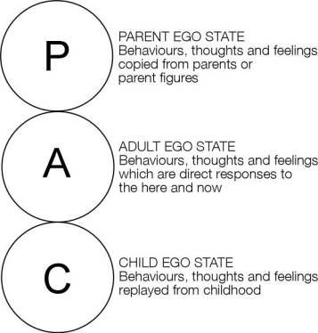
Fig. 1 PAC model
Berne observed that when people interact and begin speaking to each other, they would often switch from one state to another and this would embody a change in language, voice expressions and body language.
The Parent state contains all the
- instructions: “do this”, “don’t do that”, “you must …", “you should …" , this is the way you do it”.
- Commands: “No”, don’t”, “stop”, “do what I tell you”, “always vote Labour”, “work hard
- Rules: you can’t...”, “ always do ..” , "because I said so”
- Thoughts: “You’re good/bad/clumsy/useless/dumb/too smart/ “too shy”, “too noisy”
- Feelings “ I hate you”, I love you”, you are a scaredy-cat", “you are brave”, “you are always anxious”, “you make me angry/happy/sad”
that a non-verbal young child would hear, feel, react to, remember and recall at will, and at any age. These injunctions, both good and bad, are thought to be dominant in the first five years of age and are recorded (stored ) unedited as the “truth”. The associated verbal tone, inflection and volume plus the gestures, body positioning and facial expressions of the parental figure(s)are co-stored.
The Child state is created by the internalization of the "seeing and hearing and feeling and understanding" events in a child's early life. Harris paraphrases Aristotle : What is expressed is impressed" The “feeling" component predominates. If a child is given a caring balanced parenting ( a nurturing parent) an “I’m OK" character trait will develop. “This Free Child (FC) reflects natural, loving, carefree, adventurous and trusting behaviours and is oblivious to the rules.” If the child is badly/poorlyl treated ( by a controlling or critical parent or a "pig parent”) then a I’m Not OK" character trait (a rebellious child or a adaptive/suppressed child) will develop.
The Adult state is balanced, rational, data acquiring-processing-storing, and is in constant contact with the Parent and the Child states. The Adult state is in the ‘now’, the present. The fully functioning Adult is acting out Aristotle’s “nous” and “practical thinking” and the Child and the Parent are but echoes of the past.

Ego state | Typical words/phrases | Typical voice tone | Typical behaviour | Typical attitudes
Critical Parent (CP) | That is disgraceful. | Angry | Furrowed brow  Pointed finger  Pounding on table | Judgemental  Authoritarian
Nurturing Parent (NP) | I will sort it out for you. | Sympathetic | Consoling touch | Caring  Understanding
Adult (A) | When? | Calm  Enquiring | Relaxed  Attentive and aware  Level eye contact | Non-judgemental
Adapted Child (AC) | I will try hard.  Thank you. | Placating | Downcast eyes  Vigorous head nodding | Passive
Free Child (FC) | That is great. | Expressive | Clear demonstration of feelings | Spontaneous
Table 1: Examples of typical words, voice tones, behaviours and attitudes expressed by the differing ego-states during communication. Taken from Hollins Martin, C.J. (2011). Transactional Analysis (TA): a method of analysing communication. British Journal of Midwifery. 19(9): 587-593.

Often both mediatees will act out of different positions e.g. bully-boy ex-husband and sullen one-down Child position from the ex-wife. The aim of the mediator is to subtly via gesture, posture and “adult” language (I.e. conducting) shift both mediatees from an unbalanced Child or Parent state into a shared Adult state.

Games People Play
Berne observed that people will often play games when communicating( transacting) with another. By games he meant a two tiered dialogue with an inoccuous message and a hidden often malicious or distorted lifeview message. He gave these games colloquial names like:
“Now I’ve got you, you son of a bitch”
“Poor me”
“Let’s you and him fight”
“Look how hard I’ve tried”
“Why don’t you, Yes, but”

A common game played within a mediation is the “Now I’ve got you” game. Here one mediatee has overspent or is unable to repay for an item and becomes upset when sent a summons for payment. The plaintiff is painted as a ‘bad’/rotten person and is verbally attacked by the debtor mediatee for taking such a vicious, unfair court action. Anything the plaintiff says is disparaged, twisted or turned back onto the plaintiff. The debt is almost forgotten, side-tracked by the debtor’s verbiage and vilification. If the mediator or the plaintiff tries to focus on the debt, the debtor will often resort to a “poor me” game - too poor to pay because of Covid 19 or pension or Low study allowance or not enough to live on. The aim is to not have to pay anything, or at worst, pay a pittance on a protracted time payment scheme. The debtor will often shift from aggravated Critical Parent to wheedling Child mode.
The mediator’s task is to recognise the game and keep returning the dialogue to the debt and an obligation to repay. This often shifts to a “see you in court” game, usually as a bluff or in a misguided view that the Magistrate will believe his/her plight and perhaps even award damages for the stress generated. More work for the mediator in one-on-one sessions
The Karpman Drama triangle
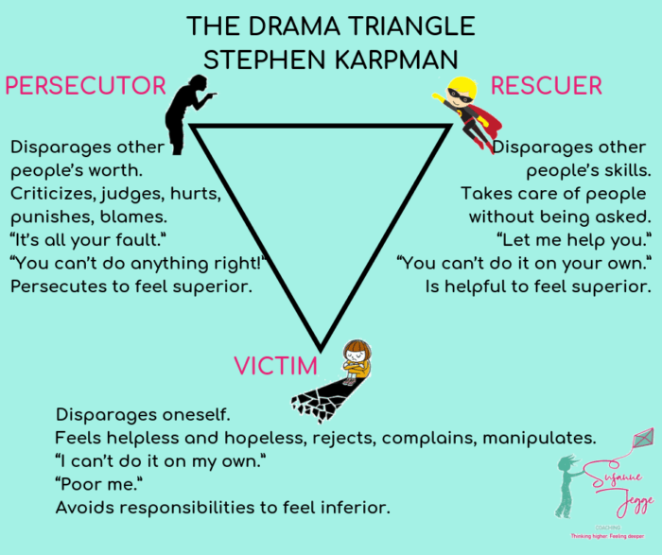
Fig.2. The Karplan Drama Triangle downloaded on 10/12/2020 from https://www.susannejegge.com/en/2019/05/29/drama-triangle-part-2/
Karplan’s drama triangle is often played out in mediation with mediatees shifting from one position to another. Power imbalance can lead to one of the mediatees being coerced into a victim role. At this point, the mediator can be sucked into the triangle often as the rescuer of the victim. The stage is for the victim to become the persecutor, and the persecutor becomes the victim. This can then lead to the victim, now persecutor, playing a “Lets you and him/her fight” game (between mediator and the other mediatee).

The Harris I’m OK You’re OK Life Choices
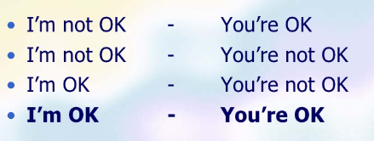
Fig. 3 Four Life Choices. Downloaded 10/12/2020 from https://www.slideshare.net/gangappalogged/im-ok-youre-ok-by-thomas-harris?next_slideshow=1
Thomas Harris a co-worker with Berne added to Berne’s modelling with his four Life Choices when comparing a person with any other person. The worst position is I’m not OK and You’re not OK. Any position on the left can be compared with any position on the right. The ultimate and best positions are I’m OK and You’re OK. This latter position may seem impossible at the start of mediation. However, with a preliminary warning that mediation is not about winning, nor getting everything, rather, it is about a “walk-away” solution, both mediatees can walk away feeling “OK”.
Conclusion
A knowledge of the basic components of TA, within a mediator’s repertoire, will enhance the listening, observational and communication skills that, in turn, can achieve a desired settlement. Articles, books and slide shows on TA are readily available, online. TA is an easy concept to understand and use within mediation, without conducting any psychotherapy.

Eric Berne,(1958). Transactional Analysis: A New and Effective Method of Group Therapy. American Journal of Psychotherapy, 12(4), 735–743. doi:10.1176/appi.psychotherapy.1958.12.4.735
Eric Berne. Games People Play
Steven Karpman.(1968). Fairy tales and script drama analysis. Transactional Analysis Bulletin, 7(26), 39-43.
Thomas Harris 1970. I’m OK –You're OK. Johnathan Cape P/L England
Harris. See 3
Hollins Martin, C.J. (2011). Transactional Analysis (TA): a method of analysing communication. British Journal of Midwifery. 19(9): 587-593.
Hollins Martin See 5
Eric Berne 1964 Games People Play. New York. Grove Press.

