M E M B E R’ S V O I C E
RESOLUTION INSTITUTE | JULY 2021

Mentor, mentorship, mentee
Part 2: Stickiness: barrier to tacit knowledge transfer

David Mitchell

There can be problems in tacit knowledge transfer between mentor and mentee.
Szulanski describes this as ‘stickiness’. Whilst explicit knowledge is easy to transfer (minimal stickiness), the more complex or tacit the knowledge or more deeply it is hidden within a mentor’s mind, the stickier the process becomes. Recognising that there is a transfer problem can lead to an examination of the process; a discovery of ‘transfer barriers’; an adoption of positive changes and a successful transfer.

Causes of knowledge transfers
At the simplest level, failure to transfer (stickiness) is a breakdown in one or more of the triadic elements (mentor-mentee-relationship) that promote knowledge transfer (see Fig 1)
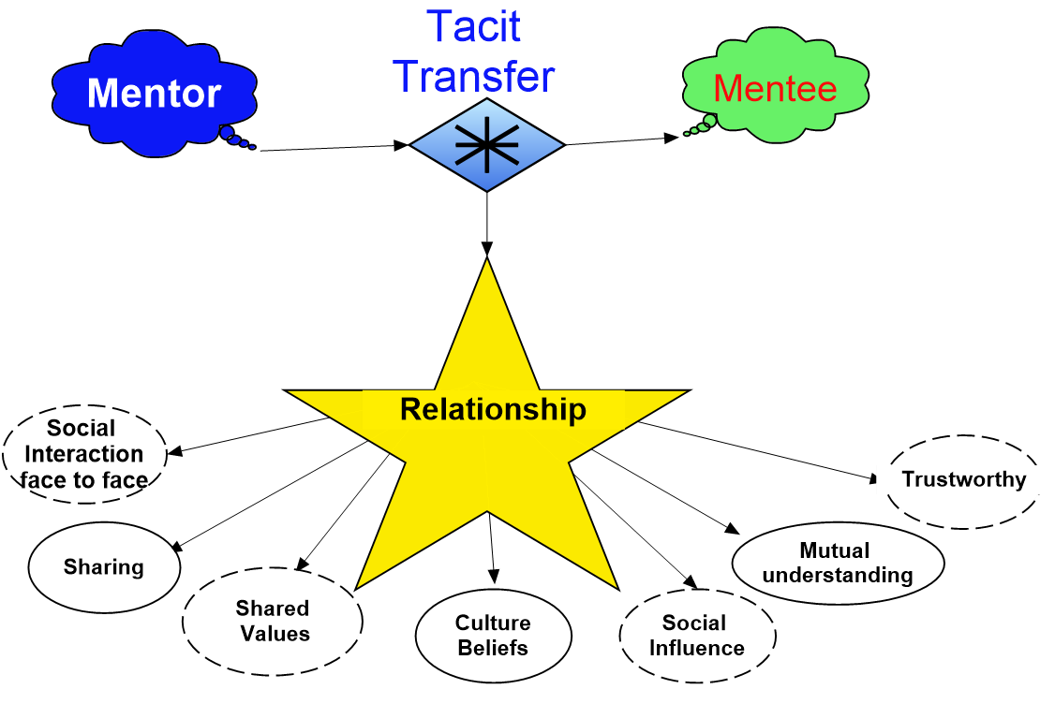
Fig.1. Stickiness can occur at any of the above interactions creating a knowledge transfer barrier.

Szulanski⁵ proposed an overall model of stickiness by identifying
a. the four stages of knowledge transfer:
Initiation
Implementation Ramp-up
Integration.
b.( i.) The characteristics of the knowledge itself
Degree of tacitness
Complexity
Robustness (flexibility and ability to adapt knowledge to differing situations)
Integrity (or completeness of transfer).

(ii). The person’s culture and context (Situational) factors
The source (e.g., mentor)
The recipient (e.g., the mentee)
The relationship between source and recipient
The organisational/professional context
Note: I have followed Murray and Hanlon’s suggestion of placing the word and concept ‘relationship’ into this list rather than Szulanski’s original heading of ‘practice’ as being more relevant. Szulanski defines ‘practice’ as an organisational unit/member (in the article this means the mentor and mentee dyad) ‘that can accomplish something on its own’

Situational factors as a cause of stickiness

‘the importance that individuals … who transfer knowledge are aware of the knowledge purpose, use, needs and gaps of the people … receiving the knowledge’

The mentor
A mentor may choose to withhold knowledge for fear of losing ownership of said knowledge or may lack motivation to transfer (e.g., not paid; no or inadequate reward; done out of hours; already worked and task overloaded). A perceived lack of credibility and trustworthiness will inhibit a mentee’s take up of knowledge as will a poor relationship. A mentor may decide that the mentee does not deserve the knowledge, doesn’t know enough to understand nor make appropriate use of it.
“… the source will only divulge their knowledge to those they deem worthy”

The mentee
A mentee can create a knowledge barrier and stickiness by exhibiting a lack of motivation, reluctance, disinterest or adopt a mindset of not needing to know. The mentee may not have the capacity to absorb the knowledge or be unable to retain it or be unable to use it.
Contrarily, Szulanski found that an over-enthusiastic, impatient, or ambitious mentee may not absorb enough knowledge, yet may try to implement the knowledge and/or possible extrapolations, fail and sabotage the reasons for the transfer.

The relationship between mentor and mentee
Failure of the mentor and mentee to establish a trusting, sharing, reciprocating, giveand-take relationship (Szulanski’s ‘arduous relationship’ ) is a common cause of stickiness. Both need to be ‘on the same page’, free to discuss their perceptions, expectations, and communication practices.

The contexts of their profession/industry
Face-to-face communication for transfer provides the most successful transfer. Cultural, language, regional and geographic barriers decrease successful tacit knowledge transfer. Organisational ignorance, disinterest or hostility will markedly reduce tacit knowledge transfer and increase stickiness.

Consequences of failed situational transfers
Where there is a failure of/barrier to tacit knowledge transfer, ‘the absence of knowledge as to why something is done’ and neither party recognises the above causes, a state of ‘causal ambiguity’ arises¹⁰. Causal ambiguity is a cause of and increases stickiness.
When can casual ambiguity and stickiness arise?
Szulanski identified four stages in tacit knowledge transfer, each possible initiators of causal ambiguity:
- Initiation …thinking, accepting the need, planning
- Implementation …transferring knowledge
3. Ramping-up … increasing and widening the use of the knowledge
- integration … the transferred knowledge ‘is socially embedded in human action, interactions and practices’.

Reversal of causal ambiguity and stickiness
The background to a reversal involves a re-established trusting relationship wherein two people work to understand, accept, motivate, share and use knowledge that is respected and valued by both. Reversal of ambiguity and stickiness requires a number of steps. Riege provides an excellent, extensive list (over 120) of possible steps and actions for large companies to take. Where there is a simple dyad of mentor and mentee there are four steps to consider in order:
- Recognise there is a problem(s) and causal ambiguity.
- Identify when (what stage in Szulanski’s model), then, why (knowledge or personality) the problem(s) arose.
- Commit to solving the problem (interacting, face-to-face dialogue, trustbuilding, sharing of culture, context, expectations, and perceptions, and, if necessary, ask for help from a more senior colleague, supervisor, or knowledge management expert)
- If ambiguity persists and/or the relationship breaks down, abandon the mentorship, and perhaps choose another member for a new mentorship dyad.

Modern solutions to mentorship
From ancient times to recent times, the sine qua non of mentorship was face-to-face interaction between mentor and mentee. Now, in the twenty first century, the universal acceptance/uptake of the web with text-based chat rooms and email, and of video communication via Facetime, Zoom and similar apps, is changing this maxim. There is now the possibility of a mentor transferring knowledge, simultaneously, to a number of mentees, via computer to anywhere in the world. Furthermore, Knowledge Management (KM) and Artificial Intelligence (AI) developments are opening avenues for storage and retrieval of both explicit and tacit knowledge (‘externalising’) via platforms like chatbots. A contrary view is driven by sociologists and behavioural scientists who maintain that the computer-driven

elimination of space (geography and social/cultural boundaries) and time is no substitute for the intimate relationship required for tacit knowledge-transfer.

Face-to-face versus virtual communication
- Face-to-face communication
‘Face-to-face settings are defined as interactions between people at the same location and at the same time’

Traditional mentorship relies on the development of a trusting, trustworthy, accepting, reciprocal relationship with common aims and expectations. This is especially so in the transfer of tacit knowledge. The giver (the mentor) has to trust the mentee to give, and the mentee has to trust the giver’s integrity and worth, to initiate reception and absorption of the gift of tacit knowledge. The social interaction is considered to be fostered by a face-to-face encounter and discourse. The body language, the facial gestures, the verbal inflections, tone, content and cultural nuances are integral in a workable interaction.

‘Face-to-face contact promotes cooperative behavior and translates into successful joint cooperation’

- Virtual communication
Virtual settings are defined as, interactions between people who are working at different locations and often in different time zones’

- A virtual verbal (chat or email and audio link) mentor-mentee relationship will miss all the visual inputs and some of the auditory and or verbal cues/ intent between mentor and mentee. Geographical and cultural boundaries can complicate the relationship. Studies have shown that virtual interaction (mentorship) becomes more task orientated and more impersonal. Ickes (1993) related this to a lack of empathic accuracy and consequent lack of compassionate action. Current thought and neuro-science has shown that an accurate assessment of a person’s distress
and a determination by the observer to act on that person’s distress is called ‘compassion’
‘Compassion has been described as a special form of empathy that involves not only having feelings of concern for the suffering of others but also wanting to alleviate it’²³
- Trust is an essential component of successful mentorship. In comparing trust development and continuance using face-to-face, video, audio, and text modalities, Bos et.al. found that ‘face-to-face is still the gold standard’, that video and audio were nearly as good as face-to-face and text the worst performer. Notably, in the video, audio and text groups, there was delayed trust and fragile trust (easily lost/broken relationships). Rocco found that a pre-face-to-face meeting before the online contact could improve the development of trust.

‘….people who have the same gender, occupation, close age, or similar expressions are more likely to detect other’s feelings accurately’ and develop trust sooner. This search for similarities can be augmented by relaxed story-telling and self-disclosure by mentor and mentee.

- Zoom /similar apps may be nearly as good as face-to-face communication.
In COVID-19 times, Zoom has become the preferred way of communicating online. However, unless the camera shows, clearly, the mentor’s and the mentee’s upper torso, arms, and face much of the non-verbal cues will be lost and can sabotage the communication. Zoom allows mentees geographically separated from their mentor to communicate and learn in real time.

- For two or more mentees within a mentorship connection, the success and ubiquitous use of Zoom-style apps can make it easier for a mentor to interact with more than one mentee. Also, the two or more mentees can collaborate in their absorption and retention of the mentor’s tacit knowledge. This can often lead to a ‘collective wisdom/knowledge gain’ that is greater than the sum of the parts.

Conclusion
Tacit knowledge can be transferred provided there is willingness to teach and to learn in a harmonious relationship. Anticipating, identifying, and overcoming ‘stickiness’ are further requirements for a complete/successful transfer. Whilst faceto-face contact is desirable, apps like Zoom can allow more mentees to learn simultaneously, no matter how distant they are from the mentor.
Part 3 of the ‘Mentor, mentorship, mentee’ series will focus on group learning via Communities of Practice (CoPs)

Gabriel Szulanski 2003.Sticky Knowledge: Barriers to knowing in the firm. Sage Strategy Series. Sage Publications, London ISBN 0761961437
Szulanski supra. Location 337 of 2736 on Kindle iOS app.
Riege, A. (2007). Actions to overcome knowledge transfer barriers in MNCs. Journal of Knowledge Management, 11(1), 48–67. doi:10.1108/13673270710728231
Murray, A., Hanlon, P. An Investigation into the Stickiness of Tacit Knowledge Transfer. 13th. Annual Conference of the Irish Academy of Management, Cork Institute of Technology, 1-3 September 2010. https://doi.org/10.21427/D7R20Q
Szulanski ibid Location 463 of 2736 on Kindle iOS app.
Riege, A. (2007), "Actions to overcome knowledge transfer barriers in MNCs", Journal of Knowledge Management, Vol. 11 No. 1, pp. 48-67. https://doi.org/10.1108/13673270710728231 .
Murray & Hanlon. ibid p.20 quoting Szulanski ibid.
Szulanski ibid location 677 Kindle iOS
Tom Broekel & Martin Binder (2007): The Regional Dimension of Knowledge Transfers—A Behavioural Approach, Industry and Innovation, 14:2, 151-175 http://dx.doi.org/10.1080/13662710701252500 ¹⁰ Szulanski ibid.. Location 590-591 Kindle iOS
Murray & Hanlon.. ibid
Schuller, M. (2014). Stickiness in knowledge transfer. In H. Hasan (Eds.), Being Practical with Theory: A Window into Business Research (pp. 61-63). Wollongong, Australia: THEORI. http://eurekaconnection.files.wordpress.com/2014/02/p-61-63-stickiness-in-knowledge-theorytheoriebook_finaljan2014-v3.pdf.
Riege, A. (2007), "Actions to overcome knowledge transfer barriers in MNCs", Journal of Knowledge Management, Vol. 11 No. 1, pp. 48-67. https://doi.org/10.1108/13673270710728231
Tom Broekel & Martin Binder (2007): The Regional Dimension of Knowledge Transfers—A Behavioural Approach, Industry and Innovation, 14:2, 151-175 http://dx.doi.org/10.1080/13662710701252500
Narendra, U. P., Pradeep, B. S., & Prabhakar, M. (2017). Externalization of tacit knowledge in a knowledge management system using chat bots. 2017 3rd International Conference on Science in Information Technology (ICSITech). doi:10.1109/icsitech.2017.8257186
Narenda et.al. supra
Behrens, F., Kret, M.E. The Interplay Between Face-to-Face Contact and Feedback on Cooperation during Real-Life Interactions. J Nonverbal Behav 43, 513–528 (2019). https://doi.org/10.1007/s10919-019-00314-1
Peter Zimmermann, Arjaan Wit and Roger Gill. 2008. The Relative Importance of Leadership Behaviours in Virtual and Face-to-Face Communication Settings. Leadership 2008; 4; 321. DOI: 10.1177/1742715008092388
Behrens, F., Kret, M.E. ibid ¹⁷
Zimmerman ibid ¹⁸
Ickes quoted in Jinjuan Feng , Jonathan Lazar & Jenny Preece (2004) Empathy and online interpersonal trust: A fragile relationship, Behaviour & Information Technology, 23:2, 97-106, DOI: 10.1080/01449290310001659240
Cheryl L Fulton. Self-Compassion as a Mediator of Mindfulness and Compassion for Others . April 2018. Counselling and Values 63(1):45-56. DOI: 10.1002/cvj.12072 ²³ Siegel & Germer, 2012 quoted in Fulton²¹ above.
BOS, N., OLSON, J., GERGLE, D., OLSON, G. and WRIGHT, Z. 2002, Effects of four computer-mediated communications channels on trust development. In Proceedings of Conference on Human Factors in Computing Systems (CHI) 2002 (Minneapolis MN, April 2002, ACM Press), pp. 135 –140.
Rocco, E. (1998). Trust breaks down in electronic contexts but can be repaired by some initial face-to-face contact. Proceedings of the SIGCHI Conference on Human Factors in Computing Systems - CHI ’98. doi:10.1145/274644.274711
Jinjuan Feng , Jonathan Lazar & Jenny Preece (2004) Empathy and online interpersonal trust: A fragile relationship, Behaviour & Information Technology, 23:2, 97-106, DOI: 10.1080/01449290310001659240
Maleszka, M., & Nguyen, N. (2015). Integration computing and collective intelligence. Expert Systems with Applications, 42(1), 332-340.

