The mediator as conductor: Repertoire
David Mitchell
Compassion and Self-compassion
The sixth article in the ‘Mediator as a conductor’ series
Musical connection. Compassion invokes a feeling for the suffering of another/others and a desire to do something about it. Compassionate music must be sad, soulful and transcend the norm and take us someplace else. . Of the multiple choices I selected four beautiful pieces: Simon & Garfunkel’s “Bridge over Troubled Waters”. Stephen Oliver’s “Lament for the Fallen”, Jan Gabarek and the Hillard Ensemble’s “Officium” and Andrew Lloyd Weber’s Requiem. The winner is: Sarah Brightman and Paul Miles-Kingston singing Lloyd Weber’s “Pie Jesu” from his Requiem.
Compassion and its place in a Mediator
“Compassion is perhaps one of the most basic virtues that might be expected of mediators.”
Compassion is slowly emerging from the empathy-induced mists of obfuscation by empathy studies to become a signification factor in health and happiness in human beings.
Compassion toward others has been associated with both cognitive and affective empathy, the healing of emotional pain, acceptance toward self
and others, decreased negative affect, and greater forgiveness .
This paper will show how compassion develops from an autonomous decision to practise self-compassion, transcends empathy, and becomes an integral part of Aristotle’s Practical Wisdom . Such a combination is an ideal fit for the emotional, and intellectual traits and persona of a mediator.

Definitions of Sympathy, Empathy and Compassion
- is an emotional reaction of pity toward the misfortune/pain/distress of another.
2 . Empathy is often divided into two or more types
a. Affective empathy, where a person experiences another’s emotions.
b. Cognitive empathy where a person tries to imagine and understand what it would be like to be in another’s shoes. This is a more detached, intellectual exercise and any action is conditional on multiple negative factors.
3. “Compassion has been described as a special form of empathy
that involves not only having feelings of concern for the suffering of others but
also wanting to alleviate it” (Siegel & Germer).
Mascaro et al define compassion, “as the deep wish that another be free from suffering, coupled with the motivation to alleviate such suffering “
The biggest difference between compassion and empathy is the compassionate desire to act or move to alleviate the suffering (or pain, stress, emotional distress, etc) of a person.
The second difference is that empathy can cause mediators to mix their emotions with those of a mediatee (contamination) or be overwhelmed by an accumulation of emotions from ongoing mediation and experience fatigue or exhaustion/burn-out. This does not happen with compassion work.
The Buddhist Connection

Sinclair et al summarise” the relationship between these three constructs from a Buddhist perspective, conceptualizing sympathy as an emotional reaction, without conscious thought and reflection. Empathy is understood as a more complex interpersonal construct that involves awareness and intuition, while compassion is defined as “a way to develop the kindness, support, and encouragement to promote the courage we need—to take the actions we need—in order to promote
the flourishing and well-being of ourselves and others”
Origins of Empathy
Psychologist and Primatologist, Frans De Waal postulates that empathy is a primal state or core element of social attraction, cooperation and imitation. This core self is unconscious .Like a Russian Doll, there is a secondary layer with a tendency for concern and consolation for another in distress and an outer or third layer of cognitive, selective perception and judgement as to the level or depth of concern (PAM or Russian Doll model hypothesis by de Waal), see Fig.1.
The core element is analogous to Ricoeur’s core “self” and the next two layers are part of Ricoeur’s “self as another” , facsimiles or part representation of the core self cloaked in the persona of a person appropriate for that situation, event, or interaction.
… a “narrative identity.” that can contain and articulate a flux of contradictory selves and their mutability within one same person/literary character in a lifetime, or in
certain periods of time.
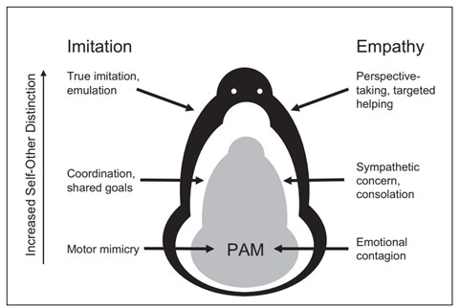.
Fig.1.The PAM hypothesis. Adapted from de Waal doi:10.1146/annurev.psych.59.103006.093625.

Origins of Compassion

Three distinct evolutionary lines for the development and presence of compassion were summarised in Goetz et al:
1. The vulnerable offspring argument: “compassion is thought to have emerged as the affective element of a caregiving system, designed to help raise vulnerable offspring to the age of viability (thus ensuring that genes are more likely to be replicated)”.
2. Sexual Selection theory: “More inclined to feel compassion during times of others' need and suffering, compassionate reproductive partners should be more likely to devote more resources to offspring, to provide physical care—protection, affection, and touch—and to create cooperative, caring communities so vital to the survival of offspring”.
3. The pro-social assumption: that compassion “evolved within a complex system of emotional states—involving liking, gratitude, anger, and guilt—which enable non-kin to initiate, maintain, and regulate reciprocally altruistic relationships”.
Compassion has always been a force in Buddhism as one of the four immeasureables :
• loving-kindness or benevolence
• compassion
• empathetic joy
• equanimity

Neurological differences between Compassion and Empathy.
fMRI studies clearly show compassion and empathy activate different areas of the brain.
empathy engages a network of brain areas centered around the anterior
insula and anterior midcingulate cortex, areas associated with negative affect, compassionate states have been associated with activity in the medial orbitofrontal cortex and ventral striatum, and come with feelings of warmth, concern, and positive affect.
Chierchia & Singer in refashioning de Waal’s PAM found that the unconscious and automatic traits of emotional contagion and mimicry followed different pathways and affects. In a compassionate person (a feeling for others) an empathic event would generate positive brain signals and a desire to help. Where the event was stressful, in the absence of compassion, the feeling with others would generate distress, withdrawal and self-centred behaviour. See Fig.2

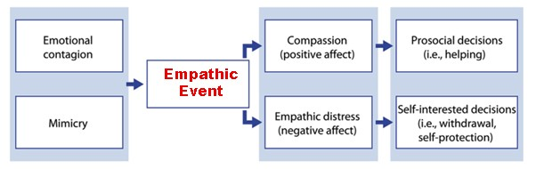Fig.2 The relationship between frequent precursors and possible consequences of empathy. Adapted from Chierchia & Singer

Benefits of Compassion for Mediators

Kristen Neff a world expert on Compassion and self-compassion has documented a number of significant benefits from actively engaging in self-compassion and compassion (taken from Neff 2003,2005,2007,2008)
- greater emotional resilience and psychological well-being
- less anxiety and depression
- increased self-esteem
- happier
- is strongly associated with emotional intelligence and Practical Wisdom.
- greater connectedness to others
- Less afraid of failure
- more intrinsically motivated to learn and grow.
- connections to Emotional Intelligence and Aristotle’s Practical Wisdom

The Development of Compassion
Compassion begins with self-compassion. To know oneself, , to understand one’s virtues and faults, to forgive oneself for any faults in thinking, for failures in behaviour and performance are essential before one can express compassion for another.
Extending compassion to the self, self-compassion, refers to a regulation strategy in which feelings of worry or stress are not avoided but instead being open and sensitive to one's own suffering, experiencing feelings of care and kindness to oneself, taking an attitude of understanding and not judging one's own inadequacies and failures, and recognizing that one's own experience is part of the common human experience (Neff, 2003).
1) extending kindness and understanding to oneself rather than harsh self-criticism and judgement.
2) seeing one’s experiences as part of the larger human experience rather than as separating and isolating.
3) holding one’s painful thoughts and feelings in balanced awareness rather than over-identifying with them.

Fig.3 Neff’s three basic components of self-compassion
Self-compassion is neither self-centeredness, selfishness nor narcissism. An open-mindedness and acceptance for oneself allows a similar (compassionate) approach to others, without corruption, contagion distress, judgement, or distortion of another’s reality (e.g., in a mediation). See fig.4.

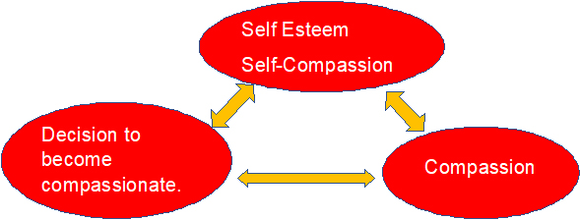
Fig.4. Author’s concept of self-self-compassion-compassion Stage 1

Following a decision to engage in self-compassion, leading to compassion for others, one needs a mechanism, technique, or practice . Mindfulness provides such a methodology.
. Mindfulness is a nonjudgmental, receptive mind state in which individuals observe their thoughts and feelings as they arise without trying to change them or push them away, but without running away with them either”

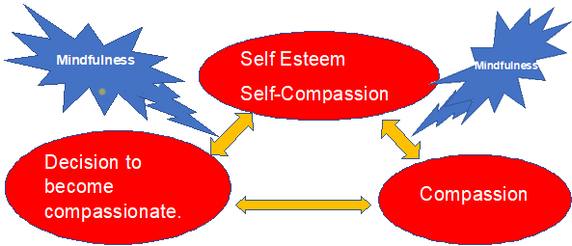

Fig.5 Author’s concept of self-self-compassion-compassion Stage 2
There is an abundance of articles, books, courses, and web sites, on mindfulness. It is easy to learn and becomes almost automatic with habituation.
Separately the Buddhist practise of Loving Kindness can achieve equivalence So too can compassion - meditation courses .
Compassion and music
One of the beguiling discoveries within compassion research has been the connection with music. In particular, ‘sad’ music.
Huon and Vuoskoski’s Pleasurable Compassion Theory suggests that one who has a compassionate trait/nature/tendency is more likely to “be moved” by such music and experience a positive or pleasurable state. This compassionate pleasure is ” typically subliminal, unconscious, and cognitively opaque”.
Further reading can be found in Wallmark et al’s review
This may partly explain why my choices of music matching this article was difficult to narrow down to one piece. I liked them all. It may well be that this musical-compassion state can be used as a compassion meter. The more one’s compassion (or progress in compassion training), the more the attraction to, and pleasure from, sad music. Alternatively, Neff has produced a workable Self-Compassion questionnaire.
Conclusion
Compassion is innate and part of human socialisation, interaction, and preservation. A mediator can utilise it personally and in mediation. It is safe, ethical, effective, self-protective and health-making. It can be taught and learnt. A fitting part of a mediator’s (as a conductor) repertoire.
David Mitchell

Barbara Wilson: In Search of Family Mediation Virtue Ethics: Picking Through the Undergrowth (September 25, 2018). Available at SSRN: https://ssrn.com/abstract=3391754 or http://dx.doi.org/10.2139/ssrn.3391754
Cheryl L Fulton. Self-Compassion as a Mediator of Mindfulness and Compassion for . April 2018. Counselling and Values 63(1):45-56. DOI: 10.1002/cvj.12072
Fulton ² above
Svenaeus F. Empathy as a necessary condition of phronesis: a line of thought for medical ethics. Med Health Care Philos. 2014 May;17(2):293-9. doi: 10.1007/s11019-013-9487-z. PMID: 24687325. Note: Svenaeus postulates that a higher form of empathy is the feeling part of Phronesis and Phronesis is the deliberative and action agent equating to compassion
Siegel & Germer, 2012 quoted in Fulton² above.
Mascaro Jennifer S., Darcher Alana, Negi Lobsang T., Raison Charles L. The neural mediators of kindness-based meditation: a theoretical model. Frontiers in Psychology Vol 6,2015 Doi:10.3389/fpsyg.2015.00109
Sinclair S, Beamer K, Hack TF, McClement S, Raffin Bouchal S, Chochinov HM, Hagen NA. Sympathy, empathy, and compassion: A grounded theory study of palliative care patients' understandings, experiences, and preferences. Palliat Med. 2017 May;31(5):437-447. doi: 10.1177/0269216316663499. Epub 2016 Aug 17. PMID: 27535319; PMCID: PMC5405806.
De Waal, F. B. M. (2008). Putting the Altruism Back into Altruism: The Evolution of Empathy. Annual Review of Psychology, 59(1), 279–300. doi:10.1146/annurev.psych.59.103006.093625
„Zorica Bečanović-Nikolić “Oneself as Another“ and „Narrative Identity“ in Shakespeare and Montaigne. Downloaded from https://www.ceeol.com/search/article-detail?id=528246. 16/02/2021
De Waal⁶ above
Goetz JL, Keltner D, Simon-Thomas E. Compassion: an evolutionary analysis and empirical review. Psychol Bull. 2010 May;136(3):351-74. doi: 10.1037/a0018807. PMID: 20438142; PMCID: PMC2864937.
Fulton C. 2018 Self-Compassion as a Mediator of Mindfulness and Compassion for Others. counselling and Values ■ April 2018 ■ Volume 63. P. 45-56
(Chierchia, G., & Singer, T (2017). The Neuroscience of Compassion and Empathy and Their Link to Prosocial Motivation and Behaviours. Decision Neuroscience, 247–257. doi:10.1016/b978-0-12-805308-9.00020-8
Chierchia, G., & Singer, T (2017). The Neuroscience of Compassion and Empathy and Their Link to Prosocial Motivation and Behavior. Decision Neuroscience, 247–257. doi:10.1016/b978-0-12-805308-9.00020-8
Chierchia, G., & Singer, T ⁸ above
Neff, K. D. (2003). The development and validation of a scale to measure self-compassion. Self and Identity, 2, 223–250.Neff, K. D., Hseih, Y., & Dejitthirat, K. (2005). Self-compassion, achievement goals, and coping with academic failure. Self and Identity, 4, 263-287. Neff, K. D., Kirkpatrick, K. & Rude, S. S. (2007). Self-compassion and its link to adaptive psychological functioning. Journal of Research in Personality, 41, 139-154.Neff, K. D., Pisitsungkagarn, K., & Hseih, Y. (2008). Self-compassion and self-construal in the United States, Thailand, and Taiwan. Journal of Cross-Cultural Psychology, 39, 267–285.Neff, K. D. & McGeehee, P. (2010). Self-compassion and psychological resilience among adolescents and young adults. Self and Identity, 9, 225-240.Neff, K.D. (2009). Self-Compassion. In M.R. Leary & R.H. Hoyle (Eds.), Handbook of individual differences in social behavior (pp. 561–573) . New York: Guilford Press.
Neff, K. D. (2003). Self-Compassion: An Alternative Conceptualization of a Healthy Attitude Toward Oneself. Self and Identity, 2(2), 85–101. https://doi.org/10.1080/15298860309032
Neff¹⁷ above
Neff¹⁷ ibid
Huron David, Vuoskoski Jonna K. On the Enjoyment of Sad Music: Pleasurable Compassion Theory and the Role of Trait Empathy Frontiers in Psychology 11 2020. DOI=10.3389/fpsyg.2020.01060
Huron ²⁰ above
Wallmark Zachary, Deblieck Choi, Iacoboni Marc. Neurophysiological Effects of Trait Empathy in Music Listening. Frontiers in Behavioral Neuroscience 12.2018. DOI=10.3389/fnbeh.2018.
Neff Self-compassion scale download from https://self-compassion.org/self-compassion-scales-for-researchers/

