The mediator as a conductor: Repertoire
Neuro-Linguistic Programming (NLP)
The second article in the ‘Mediator as a conductor’ series

David Mitchell

The second article in the ‘Mediator as a conductor’ series involves our five sensory mechanisms and their effect on thinking, behaviour and communicating. The most evocative musical piece encompassing the senses for me has been the clip from Francis Ford Coppola’s Apocalypse Now wherein the flock of helicopters, full of rockets, machine guns and soldiers wielding automatic rifles ‘dance’ to Wagner’s ‘Ride of the Valkyries’ as they destroy a Vietnamese village and its inhabitants.

The average human ‘looks without seeing, listens without hearing, touches without feeling, eats without tasting, moves without physical awareness, inhales without awareness of odour or fragrance, and talks without thinking.’
— Leonardo da Vinci

There is some truth and wisdom in da Vinci’s summation of humankind. I once drove fifty kilometres past Stonehenge (one of my bucket list items) because I was thinking of many other things and didn’t see the sign. Neurobiologists estimate we can only deal with between four and seven units of information in our working (short term) memory at once. Interestingly, if da Vinci, who wrote in mirror code, meant us to read the quote in reverse, this would then equate with the 4-7 rule controlling the unconscious uptake, assimilation and storage of our surroundings.
In the early nineteen seventies, Richard Bandler, a linguist, and John Grinder, a mathematician, found da Vinci had set out his version of the ‘da Vinci Code’ in his quote inferring ‘an internal mental disturbance would change a person’s balance in sensory perception and communication’. Bandler and Grinder were searching for a
common code or set of rules that eminent psychoanalysts in USA used in their work. Their research focused on the therapeutic interventions used by Virginia Satyr, a
family therapist, Fritz Perls, the founder of Gestalt therapy and Milton Ericson, a hypnotherapist. Bandler and Grinder found there was a code, a similarity in language, communication and interaction used by each of their therapists. Two books followed (the Structure of Magic Vols.1 & 2) and a new form of psychoanalysis and therapy was born: Neuro-linguistic programming (NLP).

NLP concepts

1. The WHAT
Bandler and Grinder proposed that:
- all memory was sensory initiated (see Chan et.al.)
- the primary sensory modes were visual, auditory and kinesthetic (touch) and a small number operated out of olfactory (smell) or gustatory (taste) modes
- people communicate via sensory representative constructs in their speech
- the sensory construct/representation may change within a conversation if communication/conversation is stalled
- a person may use different representative sensory communication modes in different social settings
- most people have a dominant sensory representative speech/linguistic mode especially under stress or duress
- a psychological distress/dysfunction was driven by a memory recall of an earlier stressful event
- the memory recall was usually an unconscious altered perception of reality, often worsening with each flare-up (see Yassa and Reagh )
- people were generally unaware of their sensory linguistic communication.
Bandler and Grinder postulated that the brain operated from a universal modelling process using two brain maps or memory modules:
- a sensory-based map or memory module incorporating pictures, sounds, feelings, tastes and smells they called ‘surface structure’. This is now part of Yassa and Reagh’s ⁶ episodic context stored initially in the hippocampus and later redirected to the neocortex. It is this area that would be relevant and useful for mediators.

- A linguistic representation of the sensory map which they called ‘deep structure’. Such a map becomes distorted and unreal from frequent use but the semantic verbal descriptors (sensory language) remain. (See Fig.2)

Bandler and Grinder had observed that when stressed, people’s narratives would contain one or more of the following masking, disruptive elements:
- distortion;
- generalisation;
- deletion.
Rather than using a narrative theory approach (inside-out) of teasing out a deeply entrenched and often distorted world-view (narrative), Bandler and Grinder decided to focus on the narrative in the now or an outside-in approach. The linguistic constructs, even though initiated years ago, could be identified in the present and changed without tampering with the life story. By changing the internal and external story-telling and the accompanying skewed linguistic pattern, a new narrative replaced the old. Some forty years after the NLP postulates were published, Yassa and Reagh have validated such a premise showing how a new memory module could be reinforced and easily and instantly made available as a model for a new persona and a new behaviour pattern.

2.The HOW
How does a mediator conduct an NLP session within a mediation?
- By identifying, in the present, the dominant sensory language used by each mediatee.
a. Were either or both fixed in the visual mode?
…If so they would use visual words, phrases, word images and metaphors
e.g. ‘I saw red when I received the plaintiff/defendant’s court action’ or ‘Why can’t he/she see what I’m getting at …’
or ‘My car/motorbike looked a mess after he/she crashed into me’ or ‘I can’t see how this matter can be resolved ….’

b. Were either/both acting out from an auditory mode?
…. If so they would use auditory words, phrases, concepts and
metaphors.
e.g. ‘That doesn’t sound right…’
or ‘Why won’t you listen…?’
or ‘You are tone deaf’ or ‘You are always yelling at me’
c. Were either/both acting out from a kinesthetic mode?
e.g. ‘Living with you is exhausting’ or ‘I don’t trust him. He is creepy’ or ‘Since this event, I’m all out of sync’ or ‘He goes hot and cold whenever….’
Table 1 lists ten of the most commonly used visual, auditory and kinesthetic words.
Visual | Auditory | Kinesthetic (Sensing)
look | sounds good/bad | exhausted
see/can’t see | won’t listen | scared/terrified
colour | music | hot/cold
view | sounds | intimidated
read | noise | pressure
picture | volume | overwhelmed
watched | deaf ears | can’t connect
mind’s eye | arguing | out of sync
movie | poor communication | helpless
Table 1. Common words/phrases in each of the three main sensory communication modes (Extracted from Rubin Alaie ⁷)

- Matching language
When the mediator has identified the dominant sensory representation (or mode) for each (and often each mediatee has a different mode), then the mediator can subtly match each mediatee’s mode, pace the conversation and slowly be drawn into that person’s worldview and narrative. Ricoeur called this ‘emplotment’. The mediator can add more positive, realistic and real options to the mediatee’s narrative via linguistic metaphors and images called ‘predicates’. Ricoeur held that a person (in this case the mediatee) could

‘meaningfully incorporate existing narratives (e.g. as suggested by the mediator….brackets added by author) into their own, through interpretation and emplotment, and through this activity open up new — and real — potentialities for the subject’s being in the world.’
Matching a mediatee’s sensory representation can be subtly used throughout a mediation but is most useful in the pre-mediation interview, in the agenda setting and within the one-on-one breakout sessions.

iii. Matching body language

This is analogous to the entrainment produced by the mediator as a conductor (See ‘The mediator as a conductor’ in Pulse, September 2020 here)

- breathing pattern: match your breathing rate to that of each mediatee in the premediation meeting, when listening to their initial narrative and during the one-on-one sessions
- posture: adjust your posture in subtle ways to approximate a mediatee's posture
- gestures: use similar hand and facial gesture when appropriate
- eye contact: to be used whenever possible as this is the ultimate way of engaging and holding a person's attention

iv. Matching voice tone.

This matching is very important where mediation is done over the phone as the visual component is missing.
- speed of speech
- volume of speech
- rhythm of speech
- characteristic sounds (e.g. coughs, sighs and hesitations)

The Neuroscientific validation of NLP
NLP has been heavily criticised by many researchers as being unscientific, unproven and yet another example of the California self-help movement from the seventies. This may well be at least partly true with the later ‘editions’, ‘models’, or revisions that incorporated NLP into salesmanship, sports, hypnosis and as a quick fix for memory problems. However, at the basic level, Bandler and Grinder’s universal modelling process of surface and deep structure has been validated by ongoing research by scientists into hippocampal memory storage, retrieval and decay over time.
The following is a review of current knowledge relevant to Bandler and Grinder’s basic NLP. Reading it is not mandatory for mediators but a little extra knowledge never hurt anyone. You might see what Bandler and Grinder did; it might sound good to you and you might grasp the concept.
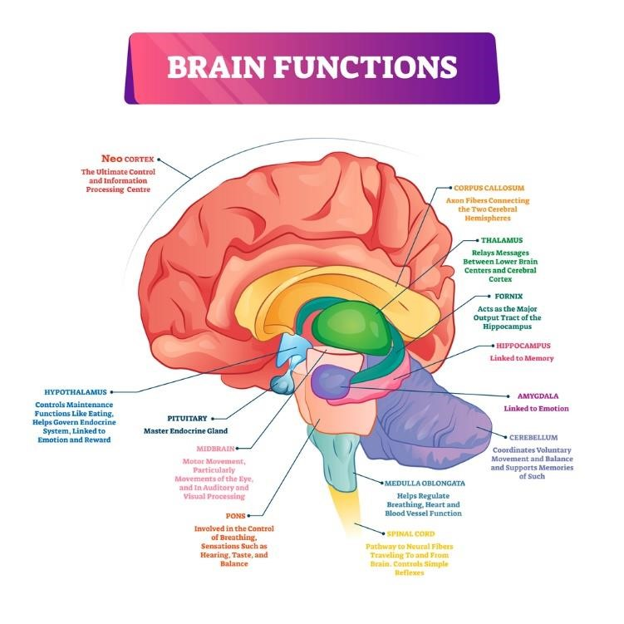
Fig.1 Memory sites in the brain
Memory can exist as short-term storage in the hippocampus and/or long term storage primarily in the neocortex (the outer regions of the brain — see Fig.1). Initiation of memory comes from sensory impulses (visual, auditory, kinesthetic,
olfactory and gustatory) via the limbic system (hippocampus, cingulate cortex, olfactory cortex, and amygdala) and emotions from the hind brain. The hippocampus encodes these signals as episodic modules that are placed/embedded in the neocortex and other parts of the brain. Similar memory modules overlap each new module. Once this occurs the hippocampus no longer stores that memory. Instead it indexes it, so that if that memory is called for, it can be rapidly retrieved from the neocortex as vivid sensory and perceptual constructs. With repeated memory recall that original module is blended with the overlapping parts of similar modules. It is accurate but changed, recoded by the hippocampus and stored in the neocortex. Over time these blended memory modules can become strengthened and independent of the hippocampus (i.e. can operate directly out of the neocortex). With repeated recall these memory constructs lose their contextural richness and accuracy (decontextualised) and become more semantic (factual, lacking sensory and emotional impact) and often inaccurate. Yassa and Reagh suggest this is a continuum (see Fig.2)

Memory storage and retrieval
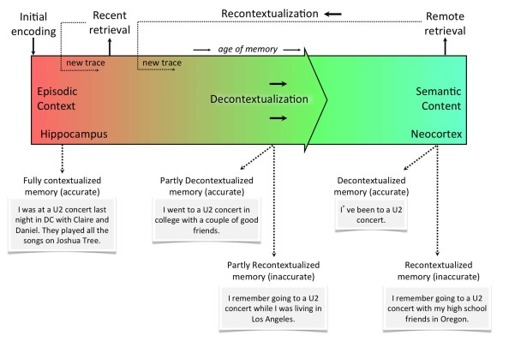
Fig.2. Memory storage and retrieval continuum Taken from Yassa and Reagh

Conclusion
Bandler and Grinder’s sensory mapping and linguistic communication modes, in a person under stress or affected by a recall of a previous stress or shock
match da Vinci’s quote. Such a person would be one who
‘looks without seeing, listens without hearing, touches without feeling, eats without tasting, moves without physical awareness, inhales without awareness of odour or fragrance, and talks without thinking.’
Bandler and Grinder cracked the code and showed the world how to rectify the sensory anomalies, leading to better functioning.

The Notebooks of Leonardo da Vinci- Complete. Project Gutenberg Ebook 2004 Translated by Jean Paul Richter 1888. Downloaded: http://www.gutenberg.org/ebooks/5000
Norman Cowan. The magical number 4 in short-term memory: a reconsideration of mental storage capacity. Behav Brain Sci. 2001 Feb;24(1):87-114; discussion 114-85. doi: 10.1017/s0140525x01003922. PMID: 11515286.
George Miller. The magical number seven, plus or minus two: some limits on our capacity for processing information. 1956. Psychol Rev. 1994 Apr;101(2):343-52. doi: 10.1037/0033295x.101.2.343. PMID: 8022966.
Richard Bandler and John Grinder Structure of Magic Vol.1 & 2
Russell W. Chan, Alex T. L. Leong, Leon C. Ho, Patrick P. Gao, Eddie C. Wong, Celia M. Dong, Xunda Wang, Jufang He, Ying-Shing Chan, Lee Wei Lim, Ed X. Wu . Hippocampus drives functional connectivity. Proceedings of the National Academy of Sciences Aug 2017, 114 (33) E6972-E6981; DOI: 10.1073/pnas.1703309114
Michael A.Yassa and Zachariah M. Reagh Competitive trace theory: a role for the hippocampus in contextual interference during retrieval. Frontiers in Behavioral Neuroscience. August 2013 | Volume 7, Article 107 doi: 10.3389/fnbeh.2013.00107
Michael A.Yassa and Zachariah M. Reagh Competitive trace theory: a role for the hippocampus in contextual interference during retrieval. Frontiers in Behavioral Neuroscience. August 2013 | Volume 7, Article 107 doi: 10.3389/fnbeh.2013.00107
⁷ Rubin Alaie. Representational systems: is someone visual, auditory or kinesthetic?. Downloaded 22/11/2020 from https://happyrubin.com/nlp/representational-systems/ Rubin Alaie. NLP Predicates – The best examples [Lists with words] Downloaded 22/11/2020 from https://happyrubin.com/nlp/predicates
Paul Rhodes 2016. Paul Ricoeur and Narrative Identity. Why we are our story . Psychology Today. ricoeur-and-narrative-identity Downloaded 22/11/2020 from https://www.psychologytoday.com/au/blog/post-clinical/201604/paul-
Wim Pouw, James A. Dixon.2019 Entrainment and Modulation of Gesture–Speech Synchrony Under Delayed Auditory Feedback. Cognitive Science 43 (2019) e12721 DOI: 10.1111/cogs.12721
Joseph O’Connor. NLP workbook 2001. The practical guidebook to achieving the results you want. Thorsons Publishers UK. Downloaded22/11/2020 from https://doc.lagout.org/science/0_Computer%20Science/3_Theory/Neural%20Networks/Neuro%20Lin guistic%20Programming%20WorkBook.pdf
Russell W. Chan, Alex T. L. Leong, Leon C. Ho, Patrick P. Gao, Eddie C. Wong, Celia M. Dong, Xunda Wang, Jufang He, Ying-Shing Chan, Lee Wei Lim, and Ed X. Wu. Low-frequency hippocampal–cortical activity drives brain-wide resting-state functional MRI connectivity. PNAS August 15, 2017 114 (33) E6972-E6981; first published July 31, 2017; https://doi.org/10.1073/pnas.1703309114
Michael Yassa, Zachariah Reagh . 2013. Competitive Trace Theory: A Role for the Hippocampus in Contextual Interference during Retrieval .Frontiers in Behavioral Neuroscience Vol7 . Downloaded 21/11/2020 from: https://www.frontiersin.org/article/10.3389/fnbeh.2013.00107. DOI=10.3389/fnbeh.2013.00107
Yassa & Reagh Ibid

